2021-2022 Recertifying Sustainable School Guide – 5th APPLICATION AND BEYOND ONLY

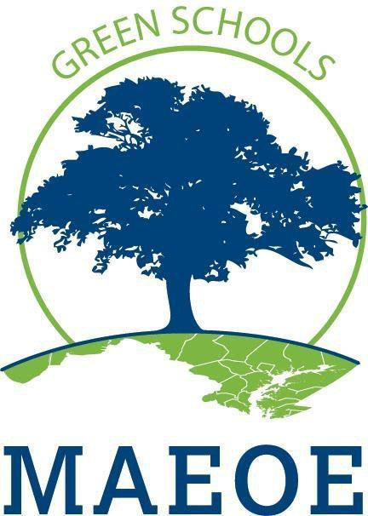  MARYLAND GREEN SCHOOL  PROGRAM | A guide for the Maryland Sustainable Green School Application. The application has been divided into sections so you can print sections as needed.  Use this guide if you are a Sustainable School and submitting application 5 and beyond.  Maryland Association for Environmental and Outdoor Education
SY2022 COVID Modification:
Throughout this guide, review the red boxes to see how the Green Schools program has been modified this year due to COVID-19. We anticipate that the application process for the 2022-2023 SY will revert to the original application process, without modifications.

Contents
Introduction 2
Getting Started 4
Application Checklist: Recertifying Sustainable Schools 5
Guide to Maryland Green School Documentation 6
Objective 1: Systemic Sustainability 6
1.1 Curriculum and Instruction: Environmental Issue Instruction 6
1.2 Professional Development 8
1.3 Sustainable Schools 9
Objective 2: Student-driven Sustainability Practices 9
2.1. Water Conservation/Pollution Prevention 10
2.2. Energy Conservation 10
2.3. Solid Waste Reduction 10
2.4. Habitat Restoration 11
2.5. Structures for Environmental Learning 11
2.6. Responsible Transportation 11
2.7. Healthy Home/School Environment 12
2.8 Citizen Science / Community Science 12
Objective 3: Community Partnerships, Awards and Special Recognition 13
Community Partnerships 13
3.1.1 School Active in Community 13
3.1.2 Community Active in the School 13
COVID-19 ADDENDUM FOR SCHOOL YEAR 2021-2022 15

Introduction
This sustainable school guide is intended to be used by schools that have achieved Maryland Green School sustainable school status. Any school achieving Sustainable School Status will now move into the next tier of the Maryland Green Schools Program. If your school achieved sustainable school status in March 2017 or earlier this guide will help you to achieve the next tier of the sustainable school award which is the bronze level.
The MAEOE Maryland Green School award program began in 1999 and allows a school to demonstrate that by integrating hands-on, inquiry-based instruction, youth are empowered to practice environmental sustainability. At school, home, and in their communities, schools are reducing pollution, decreasing waste, increasing habitat, limiting carbon emissions, creating healthy learning, and living environments and supporting environmental literacy. The program is designed to highlight achievements and progress that schools are making towards environmental sustainability, aligned with the Maryland Environmental Literacy graduation requirement as set forth in COMAR 13A.04.17.01 and the Environmental Literacy Goal established in the Chesapeake Bay Agreement. MAEOE encourages, engages, and empowers the community to understand, responsibly use and promote the natural world.
Keep in mind that multiple parts of your application connect with Maryland College and Career Ready Standards including:
- NGSS (Next Generation Science Standards) curriculum
- Maryland Content Standards
- C3 curriculum
- STEAM curriculum (Science Technology Engineering Arts and Math)
- Pressing environmental issues including climate change, decreasing biodiversity, nitrogen cycle, aquifer depletion, endangered species, habitat loss and other issues
- Meaningful Watershed Educational Experience
- Chesapeake Bay Backpack Resources
Throughout the application, you will find examples that show some of these connections
The Association of Independent Maryland & DC Schools (AIMS) recognizes that an understanding of the natural world and the impact humans have upon it is an educational and institutional value.
Accordingly, we encourage our schools to foster and support substantive environmental education experiences for all students and to seek to model sustainable practices within our physical plant operations and our school leadership practices.

- August 2019
SY2022 COVID Modification:
Throughout this guide, review the red boxes to see how the Green School program has been modified this year.

MDGS Sustainable School Application Summary
Administrative Items
Intent to Apply form and $75 fee due December 17, 2021
Cover Sheet – include with application and in a separate email due March 17, 2022
Brief Summary – in application, embed a short description about your school and its green culture
Top 5 Accomplishments – in application and Metrics Survey, embed one sentence per accomplishment
Metrics Survey – View the PDF version of the data you will need, then enter it in one sitting into the on-line survey.
Goals: Reflection on previous goals and set new 4-year goals
Application will be presented in a Chart format (see example here) Photo documentation welcome, but not required
MD Green Schools Youth Summit – to be determined
Objective 1: Curriculum and Instruction
1.1 Environmental Issue Instruction – Chart with lesson name, date, 1-2 sentence description - photos optional
Elementary/MS: instruction in all grades. HS: instruction in at least 4 subjects
1.2.1 Professional Development – Full Staff Awareness
All staff know of MAEOE Green School Application
1.2.2 Professional Development – 10% of teaching staff with recent environmental education
At least 10 % have environmental education professional development within the last 4 years
1.3 Sustainable Schools – School Wide Environmental Behavior Change
At least one non-student driven practice
Objective 2: Student-driven Sustainability Practices
A minimum of four Sustainable practices, each with 1 example of student involved/driven activities in each. Ideally,
most students in the school will be involved in at least one practice, a breadth of ages and grades would be seen on the application. Chart activity with name, date,1-2 sentence description, and metrics. EXAMPLES IN ADDENDUM.
2.1 Water Conservation/Water Pollution Prevention
2.2 Energy Conservation
2.3 Solid Waste Reduction
2.4 Habitat Restoration
2.5 Structures for Environmental Learning
2.6 Responsible Transportation
2.7 Healthy School Environment
2.8 Citizen Science / Community Science
Objective 3: Community Partnerships, Awards, and Special Recognition
Partnerships -Chart with partner name, date, 1-2 sentence description of activity or project
3.1.1 School active in the community
At least 1 ongoing, sustained partnership where the school is active in the community with a partner
3.1.2 Partner active in the school
At least 1 ongoing, sustained partnership where a partner is active in the school (can be same partner as 3.1.1)
3.2 Awards and Special Recognition (Optional)
Describe any awards received for greening activities

Getting Started

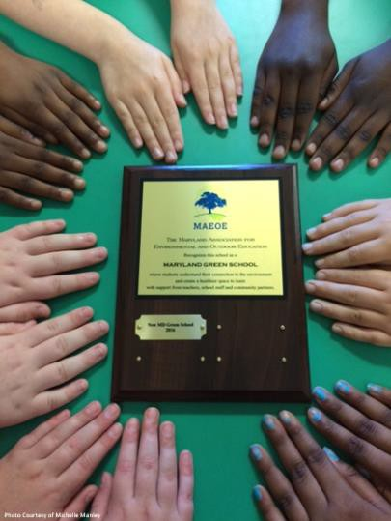
Contact your Green Center or Green Leader. Your Green Center or Green Leader can provide assistance with the application process. See MAEOE’s website for a list of Green Centers in your area. MAEOE strongly recommends that you speak with a Green Center or Green Leader at least once during your process. Nearly all successful applicants have used a Green Center or Green Leader to review their applications or give assistance at least once. If you do not have a Green Center or Green Leader, contact greenschools@maeoe.org.

MAEOE recognizes you were never expecting complete another green school application. We also know you have a strong sustainable culture embedded in your school. MAEOE would like to celebrate what you have been doing to stay green since your last Green School Award. We

have simplified the sustainable school application process. For this application, make a list of all the green activities from the past several years, photos are welcome but not required. You can include information and documentation from next school year, this school year, (see COVID-19 modifications) and the previous school years (fall 2020-spring 2021); you may also include information and documentation from Fall 2019-Spring 2021.

Applications must be electronic – either a website (using Weebly, Google Sites, or similar) or a presentation (using Power Point, Google Slides, or similar). Applications should be in a Chart format. If you have any questions about this, please contact greenschools@maeoe.org.

Consider applying for joint certification with Eco-Schools USA. The MAEOE/Eco-Schools partnership provides national and international networking opportunities, additional resources to support your school and curricula greening efforts, and increased visibility for your school and students. Visit the Green School Application page on the MAEOE website Contact Holly Gallagher at gallagherh@nwf.org for more information. Eco-Schools pathways align with the MAEOE Sustainable Practices. https://www.nwf.org/eco-schools-usa.

Review the Frequently Asked Questions (FAQs) on the Green School Application page on the MAEOE website for additional information. For specific inquiries, contact your local Green Center or email greenschools@maeoe.org

View and example of the Chart format on the MAEOE website (Requirements to Apply/Applications 5 and Beyond).

Application Checklist: Recertifying Sustainable Schools

Complete and submit the following required application materials.
- Intent to Apply Form and Fee: Complete the Intent to Apply form on the MAEOE website and pay the
$75 fee to MAEOE by December 17, 2021. Mail checks payable to MAEOE or pay by credit card online.
- Cover Sheet: Download and complete the cover sheet, which must have an original signature by the principal. Submit this separately from your application, either by email or mail. You may also embed it into your application. Note: The cover sheet for this application will be uploaded to the MAEOE website in summer 2021.

One-page summary: In your application, include a brief description (no more than one page) of your school’s green culture and the examples of sustainable changes that the school has made to become greener.

One-page goal summary: In your application, please describe your green school goals for the next 4 years, in a one-page outline. In the outline, include how to make them successful, the people who will be involved, and what outcomes you expect from the goals.

Top five accomplishments: In your application and in the Metrics Survey (see below), include a bullet list for each accomplishment that will be read at the Youth Summit Awards Ceremony. Limit your description to one sentence per accomplishment.
- Metrics Survey: Review the PDF of the Metrics Survey to gather all needed information, then, complete the online Metrics Survey. This data allows MAEOE to quantify students’ green achievements (e.g. the number of trees planted, miles of streams cleaned, pounds of trash collected, etc.), shows the impact of Maryland Green Schools on the environment, and provides inspiration to other schools. Note: The online metrics survey for this application will be uploaded to the MAEOE website in summer 2021.

Objectives 1, 2 and 3: Three separate reviewers will evaluate your application using this rubric. Your documentation must be fully explained with appropriate captions; remember to include dates and number of students involved. See detailed information below on each of the objectives.
- Submit by March 17, 2022.

Email all electronic applications to applications@maeoe.org by 11:59pm on March 17, 2022. Your submission must include the following:

Cover Sheet – embedded into the application and attached as a separate PDF

One-Page Summary

One-Page Goal Summary

Top 5 Accomplishments

Documentation for Objectives 1, 2 and 3

Applications received after March 17, 2022 are not guaranteed a review.

You will receive a confirmation email by no later than two weeks after you submit your application. If you do not receive this confirmation, please send an email to applications@maeoe.org.
Thank you for your interest in the Maryland Green School award program which demonstrates your school’s
progress with the Maryland Environmental Literacy requirement as set forth in COMAR 13A.04.17.
Maryland Green School Youth Summit (Date TBD)

This is a celebration for schools with successful Green Schools applications which includes fun activities, vendors, and time to explore the park. More info can be found here.

Guide to Maryland Green School Documentation
For this application you are creating a chart to document the work and activities happening throughout your school and school community. Professionals who do not know your school will be reviewing your application, so include enough information in the chart to help them understand your school. They follow a rubric and only have the information that you provide. Here is an example chart.

DO: | DON’T:
- Create a chart to organize your documentation.  - Include:  - dates  - grades  - activity/lesson names  - metrics  - number students/classrooms involved  - for PD, include specific names of staff  - 1-2 sentence descriptions for each item/category  - Photos welcome but not required | - Include any information without a date, numbers/metrics (when applicable), and a 1-2 sentence description  - Include documentation that does not prove an activity happened. It does not strengthen the application (and may, in fact, weaken it). Examples of non-documentation that should not be included:  - descriptions of programs copied from the internet  - flyers or emails advertising PD’s (instead, use specific dates and times that a specific staff member attended the PD)  - curriculum created by the school system and used by the whole system (it does not prove your school is taking special steps to be green – except when enhancing Objective 1.2)

See the MAEOE website for an Chart Template that summarizes the objectives.

Objective 1: Systemic Sustainability

Curriculum and Instruction, Professional Development, Sustainable Schools, and Celebration

Curriculum and Instruction: Environmental Issue Instruction
SY2022 COVID Modification: NONE
Suggestion: For descriptions, consider how lessons and assignments have been adapted to virtual platforms.

Demonstrate that outdoor, environment-based instruction, are occurring through hands-on, authentic lessons on environmental issues. (see MSDE Environmental Literacy Standards). It is essential to connect environmental topics to MD academic standards (Next Generation Science Standards (NGSS), MD College and Career Readiness Standards, STEAM). Use examples found in your curriculum and document student learning in your application. See example applications here.

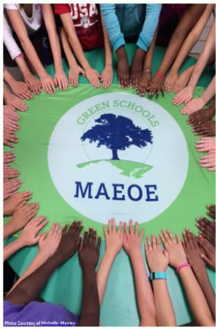
Required:

Elementary & middle schools: At least one example of outdoor and/or classroom environmental investigations instruction per grade level.

High schools: At least one example in at least four subjects for high school; can be non-science subjects, but can also be multiple science subjects, for example chemistry and biology.

All: Document in chart form lesson name, date, 1-2 sentence description - photos welcome but optional.

Examples:

A description of a MWEE, using the Environmental Literacy Model (or other format) that describes how students are participating in the Essential Elements of a MWEE: Issue Definition, Outdoor Field Experiences, Synthesis and Conclusions, and Stewardship and Civic Action. We encourage applicants to describe the MWEEs students are participating in. As a part of the Chesapeake Bay Agreement, all students must participate in a MWEE during each grade band (ES, MS, and HS).

Cross curricular activities that investigate the environment (e.g. calculate area of solar panels in math, research the history of energy use in social studies, etc.). For example, students conduct an investigation on their school grounds, then, using their findings, write a short story or poem about their experience.

Using schoolyard, community, or field trip locations for outdoor education integrated into the curriculum.

Incorporating outdoors in artwork or music education.

Activities that connect pressing environmental topics such as climate change, decreasing biodiversity, nitrogen cycle and other issues within your curriculum. For example, students learn that planting trees not only provide shade, habitat, and oxygen, but trees also take carbon dioxide from the atmosphere and store it for decades.

A community science example is using the Mosquito Habitat Mapper tool to locate the potential mosquito breeding habitats in your schoolyard and in their homes and neighborhoods. Student then develop ways to educate their community to reduce the number of human-made mosquito breeding habitats.

Compare and contrast the land cover and amount of precipitation students find in their school habitats to that of students from other countries to better understand weather and climate around the world.

Lessons on energy efficiency, pollution, clean water, reading and discussing The Lorax, are examples.

Ideas for Chart:

All: 1-2 sentence description in chart form to include number of participants and description of event - photos welcome but optional

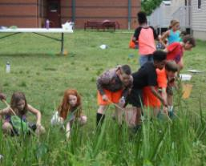
Professional Development
SY2022 COVID Modification: NONE
Suggestion: Utilize online trainings that focus on student learning through environmental literacy.

Demonstrate that all school staff know about the MAEOE Maryland Green School application, AND that staff is actively preparing to support your school’s

environmental literacy plan to help fulfill the state’s environmental literacy requirement.
Required:

All staff are aware of the Green School application process. A MAEOE Green Leader or school Green Team leader should present information at all-school staff meeting.

At least 10% of teachers have participated in an environmental education PD in the past 4 years

***Information should include dates, length of time, teachers’ names, grade levels,

and numbers of teachers. ***

Examples:

All staff are aware of the Green School application process

Staff meeting agenda includes Green School application update

Whole staff presentation provided by a Green Center/Green Leader

Principal, teachers, students, or Green Leaders present at PTA meetings

Does not have to be all at one time, may be over the course of two years and several meetings

At least 10% of teachers have participated in environmental education PD during the application period.

Staff member(s) attend(s) MAEOE conference

Staff complete the MWEE 101 Course

Staff attend environmental education workshops, e.g., Project WET, Chesapeake Classrooms, POW!, Master Naturalist, Project Learning Tree, Food, Land and People, Chesapeake Bay Foundation Professional Development, etc. Find more examples on the MAEOE Professional Development Calendar or talk to your local Green Center

Staff create accounts with The GLOBE Program and complete online training

Lesson modeling in classrooms from Green Centers or other partners

Environmental speakers presenting at staff meetings or workshops (NOT at school wide assemblies with students) **Consider speaking with your Green Leader to see if this is a possibility for them**

Environmental education-focused webinars

Climate change solutions

GLOBE Training

Ideas for Chart:

: 1-2 sentence description in chart form to include number of participants and description of event - photos welcome but optional

: 1-2 sentence description in chart form to include number of participants and description of event - photos welcome but optional

Sustainable Schools
SY2022 COVID Modification
Suggestion: Consider the changes your school has made in the distance learning model. Do any apply under this section?

These demonstrate your school’s goals towards being sustainable.
Required:

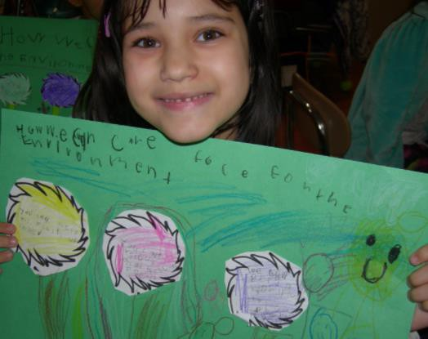
School Wide Environmental Behavior Change

    - School-Wide Environmental Behavior Changes

Demonstrate the non-student driven sustainability practices your school has taken school-wide to make your school green. If there is student involvement, the actions should be documented under Student-Driven Sustainability Practices in Objective 2.

Examples:

Staff using electronic newsletters and implementing policies to reduce paper use (i.e., double-sided copying)

Task lamps, day lighting (use of natural light), de-lamping (purposeful removal of ½ of light bulbs), or energy saver mode on electronics used by all teachers to save energy

Installation of energy-efficient lighting or motion-sensitive lights

Integrated pest management

Two-sided copying

Staff carpooling or public transportation incentive program

Reduction of impervious surfaces (blacktop, concrete) in the schoolyard

Teachers using green cleaners in classrooms

Installation of solar panels and/or green roof

Ideas for Chart: 1-2 sentence description in chart form to include number of participants and description of event - photos welcome but optional

SY2022 COVID Modification: YES
For each action, a minimum of 10 students must participate from the school. (Distance learning examples in appendix.)

Objective 2: Student-driven Sustainability Practices

Document student environmental actions and demonstrate that students are planning, implementing, and leading environmental practices. If your school has implemented a MWEE, these are the stewardship and civic action components.
Required:
A minimum of four Sustainable practices, each with 1 example of student involved/driven activities in each. Chart activity with name, date, 1-2 sentence description, and metrics. Ideally, most students in the school will be involved in at least one practice, a breadth of ages and grades would be seen on the application.

Water Conservation/Pollution Prevention

Energy Conservation

Solid Waste Reduction

Habitat Restoration

Structures for Environmental Learning

Responsible Transportation

Healthy Home/School Environment

Citizen Science/Community Science

These are student actions not adult actions. Adult sustainable actions can be documented in Objective 1.3.1

Water Conservation/Pollution Prevention

Examples:
    - Students plant rain gardens or conservation landscaping
    - Students install and use rain barrels
    - Students create and hang signage near school sinks and water fountains to encourage water conservation
    - Students remove litter from schoolyards, local parks, and streams with the activity focused on removing that litter before it reaches the waterways (stream restoration)
    - Students conduct erosion-control projects such as installing riparian buffer zones and planting trees (stream restoration)
    - Students stencil storm drains to prevent polluted water from reaching the streams
    - Students plan and create no-mow zones with identifying signage (so it will not be mowed accidentally)
    - Students create hydroponic or aquaponic gardening systems

Energy Conservation

Examples:
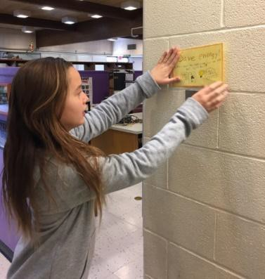
    - Students label the light switches throughout the school with signs or switch-plates encouraging energy conservation and reducing our impact on climate change
    - Students implement the results of their energy audits or encourage decision-makers to implement actions based on their data collection
    - Students perform classroom jobs to save energy, such as turning off lights & computers or closing the blinds (documentation could include a list of jobs posted in the classroom)
    - Student group forms an “energy patrol” and issues “energy stars” to classrooms that turnoff lights or electronics
    - Students plant trees to shade the building
    - Students install energy-efficient lighting in computer labs or elsewhere in school
    - Students create and read Energy Savings Tips on morning announcements

Solid Waste Reduction

Examples:
    - Student Green teams regularly monitor, track, and/or manage the school recycling bins
    - Students participate in no-waste lunches

    - Students organize recycling drives for ink cartridges, cell phones, batteries, etc.
    - Students participate in up-cycling programs such as Terra-Cycle
    - Students create labels for recycling stations
    - Students create posters to remind each classroom what to recycle
    - Students monitor and maintain an outdoor compost bin or an indoor vermicomposting (worm compost) bin
    - Students repurposed used materials into art projects
    - Students create their own recycled paper
    - Students advocate to hand in homework electronically or communicate via classroom blogs rather than with paper
    - Students run a reusable water bottle campaign, encouraging other students to use water fountains and reusable water bottles instead of store-bought plastic bottles
    - Students create and/or run a school ReStore for unused school supplies

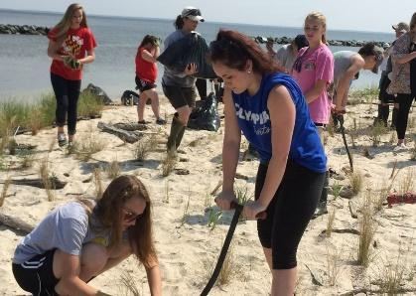
Habitat Restoration

Examples:
    - Students plant or tend a native plant garden in schoolyard (e.g., native plant butterfly, pollinator gardens)
    - Students plant native trees or native bay grasses
    - Students install/monitor bird, bat, or butterfly boxes
    - Students remove invasive plants from schoolyards or neighboring parks
    - Students construct oyster reef habitat balls
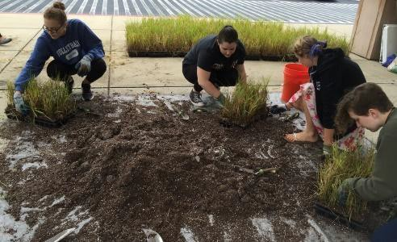
    - Students regularly monitor and care for a rotting log or brush pile decomposer habitat
    - Students build and monitor insect hotels
    - Students create and monitor a bird habitat area with food, shelter, and water sources
    - Students maintain and use schoolyard habitat

Structures for Environmental Learning

Examples:
    - Students regularly work outside in an outdoor classroom (can be fixed or movable outdoor classroom)
    - Students grow food in gardens at school (salad tables, raised bed gardens, in-ground gardens, etc.)
    - Students advocate for green building infrastructure resources at their school, such as solar panels and green roofs
    - Students create outdoor artwork for schoolyard/outdoor classrooms
    - Students build and use a nature trail around their schoolyard
    - Students post interpretative signage on interesting environmental features around the schoolyard (i.e.: erosion, decay, etc.)
    - Students identify native trees or plants in the schoolyard and create a labeled identification trail or scavenger hunt

Responsible Transportation

Examples:
    - Students survey, analyze and implement carbon reducing actions to improve school transportation issues
    - Students create a no-idling zone by posting signage and handing out fliers
    - Students run a bike safety program
    - Students participate in Safe Routes to School activities to advocate for safe routes
    - Students routinely go on walking field trips to reduce their carbon footprint and get to know local ecosystems, emphasizing the effects on climate change

    - Students conduct tire pressure/oil leak checks on faculty vehicles and inform vehicle owners of results (improper tire pressure leads to greater fuel consumption)
    - Students create carpool groups
    - Students advocate for hybrid parking and/or carpool parking
    - Students lead their school in the Idle Free MD Campaign

Healthy Home/School Environment

Examples:
    - Students make and use non-toxic or green cleaning products for classrooms
    - Students grow and donate and/or eat healthy food in school gardens
    - Students grow indoor plants to enhance air quality
    - Students organize an outdoor running or other health club that utilizes the school grounds and encourages the students to spend time outdoors.
    - Students create a poster campaign to encourage healthy eating choices while promoting the school’s garden
and the importance of local, sustainable, and organic farming (agriculture).
    - Students host a “Recycling Olympics” or “Green Run” to encourage exercise and activity while incorporating environmental action.
    - Students organize a community clean-up

Citizen Science / Community Science
Teachers initiate two or more activities that use GLOBE, GLOBE Observer, iTree, iNaturalist or other citizen science/ community science protocol to better understand the school environment and how citizen science/community science is used. Schools should have at least 1 staff member who has registered your school and completed any training required for engagement in these programs. Data submission to GLOBE/GLOBE Observer/iTree/iNaturalist/Creek Freak etc. that shows evidence of students having used at least two GLOBE/GLOBE Observer protocols or other protocols on a consistent basis over at least a two-month period or periodically over several months/years to document change over time.

Examples:
    - Students create a poster campaign to share “Best Practices” with others to learn about mosquito prevention and protection
    - Students create a poster that shares the purpose of their citizen science/community science project and data collected.
    - Students find solutions to modify locations in their school yard which are impacted by water runoff during rain events
    - Students collect data about seasons as part of climate change citizen science and submit online
    - Students look for and collect data on native ladybugs and submit information online
    - Students survey trees on the school grounds and document their growth during the school year and submit information online
    - Students take surface temperature measurements during the school year around the school grounds to demonstrate the positive impact of the shade from trees and other vegetation
    - Students monitor their school environment for potential mosquito-breeding habitats and continually eliminate these when feasible
    - Students develop solutions to improve soil as needed if their investigations show trees and vegetation on school grounds are not growing as they should
    - Students create plans for landscaping on school grounds to increase the amount of green space and maximize the positive use of shade to reduce the urban heat island effects in their locations
    - GLOBE Schools: Have students participate in the International Virtual Science Symposium and share what they have learned with other students, teachers, and scientists from around the world.

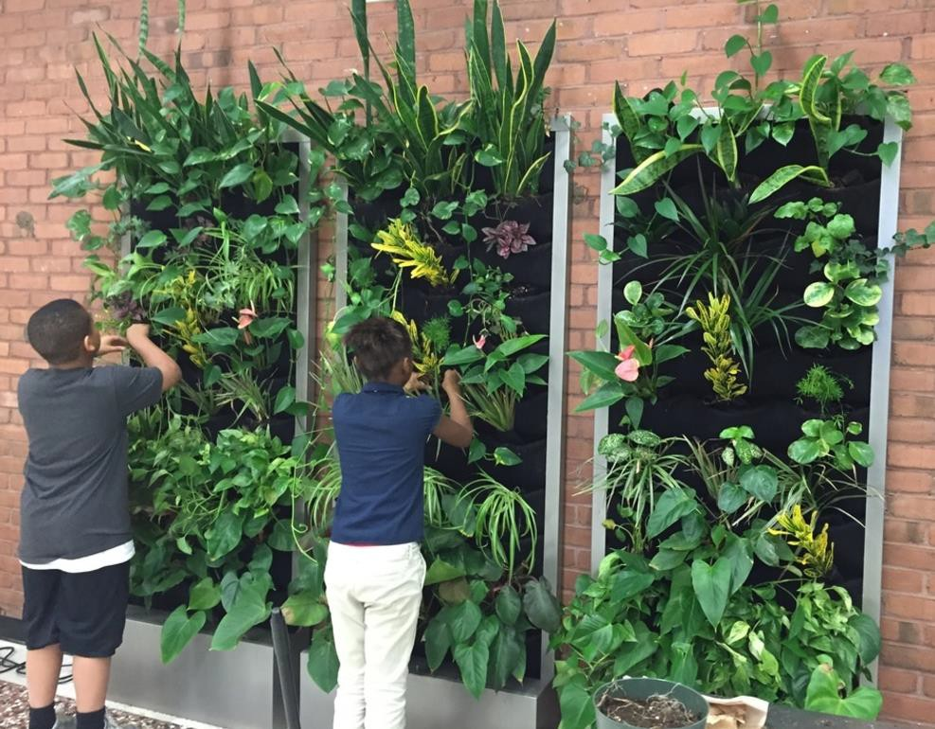

Objective 3: Community Partnerships, Awards and Special Recognition
Community partnerships are important for schools to be successful in building long-term sustainable practices.

Community Partnerships
Demonstrate who is collaborating with your school on environmental education.

Required:
One sustained partnership where the partner is active in the school AND
One sustained partnership where the school is active in the community (can be the same partner organization or a different one).

School Active in Community
Examples:
      - Students do environmental service projects off-site (e.g. stream clean-up, storm drain stenciling, invasive species removal, etc.)
      - Used-Clothing Drive, with emphasis on reusing as conservation
      - “Terrapins in the Classroom” project, release terrapins in the Bay (Other examples of similar programs include oysters, trout, monarchs and more)
      - Fundraiser at the school to support community environmental projects
      - Students run a letter writing campaign to political representatives
      - Green Festival inviting the community to learn from students’ work

Community Active in the School
Examples:
      - Green Leader comes into the school to help with activities and/or the application
      - Partner comes in to help set up an environmental project (e.g. bird boxes, rain gardens, edible gardens, outdoor classroom)
      - Receive a grant for a school environmental project
      - Environmental speaker comes to do an environmental education assembly
      - Green Festival inviting the community to exhibit and present

Possible partners: This list includes suggestions – if there are other partners your school is working with to become a green school, feel free to use them!
      - Local Green Centers/Green Leaders
      - Alice Ferguson Foundation Trash Free Schools
      - County agencies (e.g. local USDA extension service, soil conservation district, health department, library, public safety [police and fire department])
      - State agencies (e.g. DNR, MDE, MSDE, Forestry Board)
      - Federal agencies (e.g. NOAA, EPA, USDA)
      - Local businesses (e.g. Lowes or Home Depot)
      - Local garden clubs or community organizations (e.g. garden clubs, Master Gardeners, Master Naturalists, 4-H)
      - Local parks, nature centers or Maryland-National Capital Park and Planning Commission
      - Non-profits (e.g. Chesapeake Bay Trust, Chesapeake Bay Foundation, Girl/Boy Scouts)
      - Colleges and universities
      - Energy companies, waste management companies or other

Ideas for Chart: 1-2 sentence description of partnership in chart form to include number of participants and description of event - photos welcome but optional

  - Awards and Special Recognition (Optional)

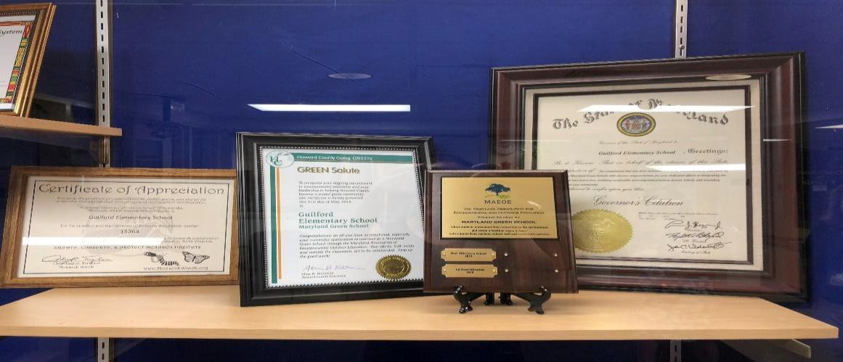
Information here enhances your application. If your school or students have received awards or special recognition, include a few sentences describing the activity, grade level, number of students who participated, and date. (This section is NOT REQUIRED)

Examples:
    - County awards (e.g. “A” grade on
recycling from the county)
    - Measurable energy savings awards
    - National awards (e.g. Green Ribbon, Blue Ribbon, Eco-Schools USA, Healthy School Award)
    - Specific Students recognized for Green efforts through scholarships, conferences, science fairs and more

Ideas for Chart: 1-2 sentence description of partnership in chart form to include number of participants and description of event - photos welcome but optional

COVID-19 ADDENDUM FOR SCHOOL YEAR 2021-2022
Due to the COVID 19 pandemic MAEOE understands this school year will bring challenges for schools, students, teachers, parents, and administrators in unanticipated ways through the various distance learning models. Please know we are here to help. Just contact us at greenschools@maeoe.org for more information.

In modifying the application MAEOE seeks to adapt the MD Green School application to the current distance learning models that will be utilized throughout the state. In recognizing that many Maryland students will be learning at home the three objectives have been modified to incorporate at home practices that will support certification. Below are recommendations that may assist in achieving MD Green School certification this school year. Out of the box thinking is encouraged. If you have questions please contact greenschools@maeoe.org.

Objective One: Curriculum & Instruction | Recommendations
1.1 Environmental Issue Instruction - ES/MS: instruction in all grades. HS:  instruction in at least 4 subjects | For documentation considering using student work as an artifact if photos are not easily obtainable or do not make sense. Online platforms such as Google Classroom  may provide an “easy” way of collecting student work submissions.
1.2.1 Professional Development – Full Staff Awareness | Work with the administrative team in the school to announce recertification plans at a virtual staff meeting. Make a copy of the meeting agenda and take a screen shot of  the attendees.
1.2.2 Professional Development – 10% of teaching staff with recent environmental education  At least 10 % have environmental  education professional development within the last 4 years | Utilize online trainings that focus on student learning through environmental literacy.
1.3 Sustainable Schools – School Wide Environmental Behavior Change  At least one non-student driven practice | Consider the changes your school has made in the distance learning model. Do any apply under this section?
Objective Two: Student-Driven Sustainability Practices | A minimum of four Sustainable practices, each with 1 example of student involved/driven activities in each. For each action, a minimum of 10 students must participate from the school.
2.1 Water Conservation/Water Pollution Prevention | Calculate water conservation at home (showers, lawn, brushing teeth, etc.); hydro/aquaponics gardening; conservation signage in the home (ex: signs in bathroom); collecting rain water at home for garden or other plants; litter pick up in  neighborhood; posting signage in neighborhood supporting anti-littering.
2.2 Energy Conservation | Adjust thermostat settings (warmer in summer, cooler in winter), adjust window shades/curtains allow sun in home for heating and cooling, light switch covers; conservation signage in the home; planting trees for shade near the house; address vampire energy (unplug appliances, computers, chargers, etc.); open windows for  cool air (during late summer or fall);
2.3 Solid Waste Reduction | Composting (at home or pick up options), reduce packaging on grocery purchases (bring your own bags, meal leftovers, recycling, reusing items, return plastic grocery  bags to store; old electronics to appropriate collection site; CFLs to Home Depot or other collection sites.
2.4 Habitat Restoration | Plant flowers or a tree outside or even inside with the intention of relocating outside when possible; build simple birdhouse with at home materials (include a link to  directions - if it exists).
2.5 Structures for Environmental  Learning | ID all the plants in the garden or in the yard (Use popsicle sticks or the like for ID);  build an area to work on school assignments in the outdoors.

2.6 Responsible Transportation | Remind parents/guardians not to idle cars when possible with signs in the neighborhood; ride your bike to pick up something for the house (when and where  safe); walking to run errands.
2.7 Healthy HOME/School Environment | Disposing of fats, oils, and grease properly; vegetarian day of meals, natural cleaners such as vinegar, indoor house plants added to the home.
2.8 Citizen Science / Community Science | "Lost Ladybug Project" and Feederwatch
Objective Three: Community Partnerships, Awards, and Special  Recognition | 3.1.1 and 3.1.2 are still Required; 3.2 remains optional
3.1.1 School active in the community  At least 1 ongoing, sustained partnership where the school is active in the community with a partner (can be same  partner as 3.1.2) | Online fundraiser which supports an environmental cause, small group community clean-up (10 or fewer people).
3.1.2 Partner active in the school  At least 1 ongoing, sustained partnership where a partner is active in the school  (can be same partner as 3.1.1) | Partners will be essential in assisting schools this year. Please reach out to an in- county Green Center or a local environmental education non-profit for support and environmental literacy programming.
3.2 Awards and Special Recognition  (Optional)  Describe any awards received for  greening activities | Let MAEOE know if the school, students, or staff are recognized.

