Maryland green Center program | Abstract  A guide for Sustainable Maryland Green Center’s Application. The application has been broken into sections so that you can print off the parts as needed.  Maryland Association for Environmental and Outdoor Education

2018-2019 Guide

Introduction
The MAEOE Green Center (GC) program was initiated in 2003 to support a growing Maryland Green Schools program. The Green Center Award recognizes Outdoor Schools and Nature Centers that model sustainable practices and support schools with implementation of environmental education. The Maryland Green School award program allows a school to demonstrate that by integrating hands-on, inquiry-based instruction, youth are empowered to practically apply knowledge. The program structure highlights the achievements and the progress that schools are making with the Maryland Environmental Literacy requirement as set forth in the Code of Maryland Regulations (COMAR 13A.04.17). The program structure also highlights the actions that schools are taking to build a sustainable future.
Green Centers offer professional learning opportunities to teachers, model sustainable practices and have activities and passive learning opportunities for visitors. Green Centers are a partner for success for schools going through the Maryland Green Schools application process. Green Centers are experienced with the Maryland Green School Application and can show how their programs and trainings align with and can be integrated into a successful application. Green Center Staff can answer questions about the application and can introduce the program to a school that is considering becoming a Maryland Green School. Green Centers are all involved in the preservation of the state’s unique natural resources, particularly those of the Chesapeake Bay and its watershed.
This application allows an outdoor school or nature center to demonstrate that they can effectively support schools with the MAEOE Maryland Green School Application process in all three objectives. Green Centers are key partners for the success of MAEOE’s MD Green School program. In addition, MAEOE and the Green Centers are collaborating with MSDE to support environmental literacy in schools Find more information about the Environmental Literacy Standards here.

Green Center staff members should be prepared to provide appropriate guidance about how to effectively infuse environmental literacy within lessons and units of instruction.
As part of the Green School application, we are encouraging schools to make connections with Maryland College and Career Ready Standards including:
- NGSS (Next Generation Science Standards) curriculum
- C3 curriculum
- STEAM curriculum (Science Technology Engineering Arts and Math)
- Pressing environmental issues including climate change, decreasing biodiversity, nitrogen cycle, aquifer depletion, endangered species, habitat loss and other issues
- Meaningful Watershed Educational Experience

Throughout the application, you will find examples that show some of these connections

Contents
Introduction 1
Getting Started: Sustainable Centers 3
Application Checklist: Sustainable Centers 4
Green Center Application Objectives Checklist 5
Objective 1: Systemic Sustainability 6
1.1 Professional Development of Teachers 6
1.2 Professional Development 7
1.3 Promoting the Maryland Green Schools program 8
1.4 Supporting MD Green Schools 8
1.4.1 Sustainable Practices Support 9
1.4.2 MD Green School Application Support 9
1.4.3 Center Based or School Environmental Student Programs 10
1.5 Center-Wide Environmental Behavior Changes (Optional) 10
Objective 2: Student-driven Sustainability Practices 11
2.1. Water Conservation/Pollution Prevention 12
2.2. Energy Conservation 12
2.3. Solid Waste Reduction 13
2.4. Habitat Restoration 13
2.5. Structures for Environmental Learning 14
2.6. Responsible Transportation 14
2.7. Healthy School Environment 15
Objective 3: Community Partnerships, Awards and Special Recognition 16
3.1. Community Partnerships 16
3.2. Awards and Special Recognition (Optional) 17
Guide to Maryland Green Center Documentation 18
IMPORTANT FILING INFORMATION AND DATES FOR 2018/19 19

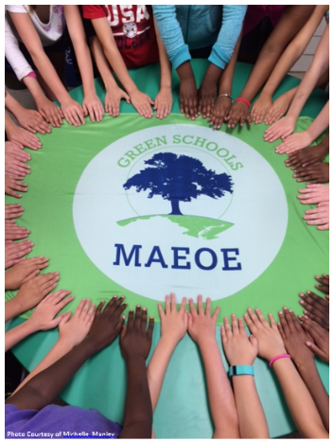
`

Getting Started: Sustainable Centers

- Reestablish your Center’s green baseline by making a list of all the Center’s green activities from the past two years, including photos. This will help you put your application together.
- Set up a website, Weebly, Prezi, Power Point, or similar method of electronically logging your Center’s application information and documentation during the application process.
  - This can be updated by staff members as events/training/practices/programs/partnerships occur over the two-year process.
  - This is a recertification, you may include information and documentation from this school year and any of the previous three school years (2015-2019).

- Maryland Green Centers are required to input their center’s Sustainable Practices into our Metrics Collection Survey. This will allow MAEOE to quantify Maryland’s green achievements through data tracking (e.g. the number of trees planted, miles of streams cleaned, pounds of trash collected). This data can then be used to find inspiration in other school’s and center’s projects and see the impact MD Green Centers have on the environment. See page 4 for more details and the link for the Metrics.

- File your Intent to Apply and pay the fee by December 14, 2018. The fee of $100 must be paid to MAEOE either by check or credit card. See page 19 for more details about filing the intent to apply.

For more information please go to www.maeoe.org/green-centers or contact mailto: greenschools@maeoe.org

Application Checklist: Sustainable Centers
Complete and submit the following required application materials.
___ Intent to Apply Fee: Fee of $100 must be paid to MAEOE by December 14, 2018. See page 20 for more details about filing the intent to apply.
___ Cover Sheet: must have an original signature by the head of your organization. Please submit this separately from your application (either by email or mail). You are welcome to also embed it within your application. You will find this on the Green Center Application Page.
___ Brief reflection summary: This is a one-page report describing your center’s green culture and significant changes that the school has made. This is a brief summary (one page), illustrating how your organization is representative of a Sustained Maryland Green Center. Explain how your center and its community has built and embraced the “Green” culture over the 14 years of the Maryland Green Center application process. This is your opportunity to highlight your achievements and outline how you maintained this award through 14 years of transitions. Please submit no more than one page. Please submit this within the main application.
___ Brief goal summary: In your application, please describe your green center goals for the next 4 years, 8 years, and 12 years in a one page outline. In your outline, include how to make them successful, the people who will be involved, and what outcomes you expect from the goals.
___ Brief top five accomplishments bullet-list: please include one sentence for each of the accomplishments. Please submit no more than one sentence for each bullet point. Please submit this within the main application and in the Metrics. These will be read at the Youth Summit Awards Ceremony.
___ Metrics Collection: Review this PDF of the Metrics Collection to collect all the information before starting. Then enter your data and “top Five” accomplishments into the Survey Monkey Metrics Survey here.
___ Documented Application Objectives: your application will be evaluated using the rubric on the information AND documentation that your school provides for each objective. Documentation must be fully explained with appropriate captions. In your application do not forget dates and number of students involved. Examples of how you can meet the objectives are found on pages 3-11. Past applications and the rubric can be found on the Green Center Application page at www.maeoe.org. Applications are due no later than March 18, 2019.
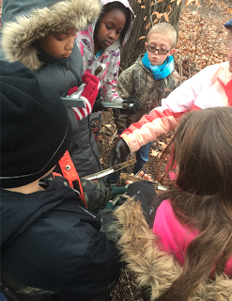

Green Center Application Objectives Checklist
This is a way to organize your school’s application. This form is available online. To access it, click here.
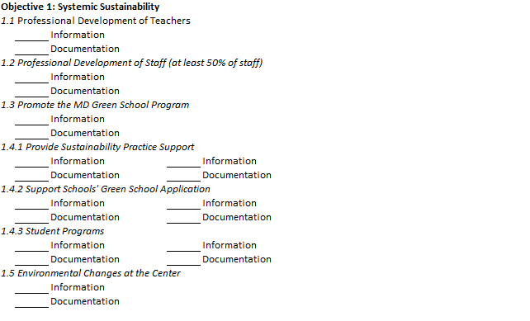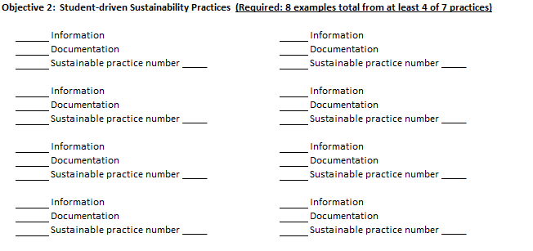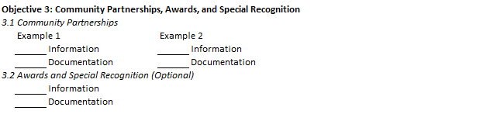

Objective 1: Systemic Sustainability
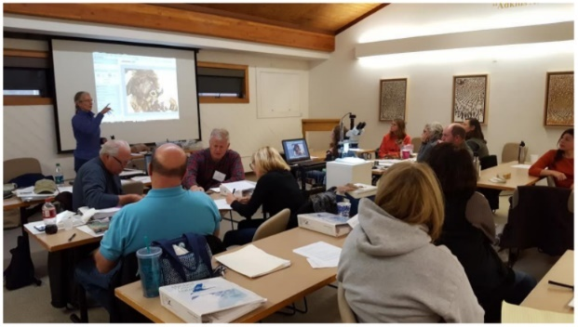
Curriculum and Instruction, Professional Development, and Celebration

1.1 Professional Development of Teachers
MD Green Centers must demonstrate that they are conducting or facilitating professional development for teachers at the Green Center or by going to the school
Required: Provide Professional Development Opportunities for local schools. Each activity should include at least one piece of labeled documentation.
Acceptable: 1 example
Good: 2 – 4 examples
Excellent: 5 + examples
Examples: Activities that enhance environmental awareness, literacy, knowledge, skills, and/or related instructional strategies.
- Partner with outside organizations to deliver Professional Development (e.g. Project WET, Chesapeake Classrooms, POW!, Master Naturalist, Project Learning Tree, Food, Land and People, etc). Find more examples on the MAEOE Professional Development Calendar
- Lesson modeling or planning in classrooms
- Environmental speakers presenting at staff meetings or workshops (school wide assemblies with students do NOT count as Professional Development)
- Environmental Education focused webinars
- Integrating pressing environmental concerns including climate change, decreasing biodiversity, nitrogen cycle and other issues into the classroom
- Connecting NGSS, STEAM and C3 to environmental instruction
Ideas for Documentation: (NOTE: ALL documentation should be captioned with text explaining the grade level/subject area and any necessary explanation of the activity!)
- agendas
- promotional flyers
- emails about the training
- sign-in sheets
- photos at Professional Development session

1.2 Professional Development
MD Green Centers should have staff members that are involved in their own professional growth on a yearly basis. Information should include dates, length of time and name of the participant, name of the workshop or professional development attended.
Required: At least 50% of center teachers/staff have participated in Environmental Professional Development during the past two years. Each activity should include at least one piece of labeled documentation.
Acceptable: 50% of the staff
Good: 75% of the staff
Excellent: 100% of the staff

Examples:
- Staff member(s) attend(s) MAEOE conference
- Staff attend environmental education workshops (For example: Project WET, Chesapeake Classrooms, POW!, Master Naturalist, Project Learning Tree, Food, Land and People, etc). More examples provided on the MAEOE Professional Development Calendar
- Maintenance staff take Integrated Pest Management (IPM)
- Environmental landscaping course
- National Association for Interpreters training with environmental component
- Energy saving presentation given at a staff meeting by BGE, USGBC, EPA Energy Star Program and other professionals
- Environmental webinars/TED Talks
- Collaborative or Strategic Planning with staff to discuss and strategic plan about the Environmental mission of the organization or the sustainability of the center
- MD Green School Reviewer Training

Ideas for Documentation: (NOTE: ALL documentation should be captioned with the specific names of staff involved, dates, and any necessary explanation of the activity!)
- Agendas
- Certificates of completion or participation
- Email confirmations/registrations
- Sign-in sheets

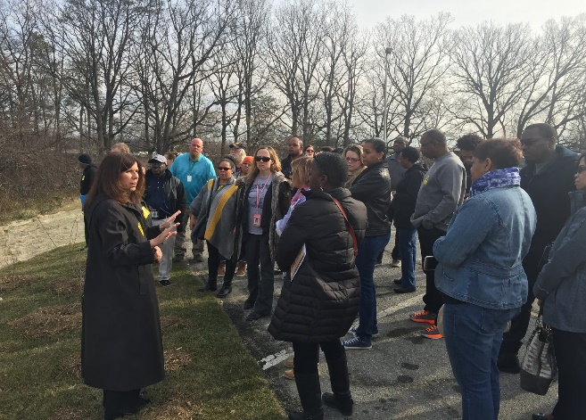

1.3 Promoting the Maryland Green Schools program
As a Maryland Green Center you are required to promote the MAEOE Maryland Green School program. MAEOE expects every center to have MD Green School program. Green Centers should promote the MD Green School program to the schools with which you currently work. Green Centers can use their connection to the MD Green School program as an introduction to schools with which the Center would like to begin work.
Required: One example of how your Green Center promotes the MD Green School program. Each activity should include at least one piece of labeled documentation.
Acceptable: One Example
Good: Two-three examples
Excellent: Four or more examples

1.4 Supporting MD Green Schools
Demonstrate how your center supports the MAEOE Maryland Green School Program.
Required: Two examples of each of the following Maryland Green School supports: Sustainable Practices Support, MD Green School Application Support and Environmental Student Programs. Your application will contain at least 6 examples. Each activity should include at least one piece of labeled documentation.
Green Center staff members should be prepared to provide appropriate guidance about how to effectively infuse environmental literacy within lessons and units of instruction.
As part of the Green School application, we are encouraging schools to make connections with Maryland College and Career Ready Standards including:
- NGSS (Next Generation Science Standards) curriculum
- C3 curriculum
- STEAM curriculum (Science Technology Engineering Arts and Math)
- Pressing environmental issues including climate change, decreasing biodiversity, nitrogen cycle, acquifer depletion, endangered species, habitat loss and other issues
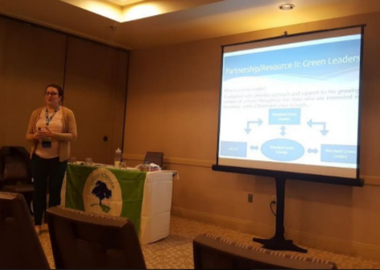
Acceptable: Two-three examples for 1.4.1
Two-three examples for 1.4.2
Two-three examples for 1.4.3
Good: Three-four examples for 1.4.1
Three-four examples for 1.4.2
Three-four examples for 1.4.3
Excellent: 5 or more examples for 1.4.1
5 or more examples for 1.4.2
5 or more examples for 1.4.3

1.4.1 Sustainable Practices Support
Examples:
- Financial support and/or assisting with grant information and grant writing.
- Providing materials, trees, plants, volunteers.
  - Building a Rain Barrel with a School
  - Providing curriculum resources
  - Providing Nature Boxes for educators
  - Providing or creating storm drain stenciling kits with a school
  - Providing recycling containers
  - Providing water and/or energy conservation signage
- Providing technical support for planning and implementation of projects.
- Providing contacts and connections to the appropriate resources.
- Partnering with schools to design solutions to environmental issues in the community.

1.4.2 MD Green School Application Support
Examples:
- Assist with the setup of an online application
- Review MD Green School Applications (including at the MAEOE Conference)
- Give Green School process presentation at schools
- Meet with School Green Team(s) to help put together an application
- Answer emails and questions about the Green School Process
- Encourage/Support Staff to become trained as a Green Leader
- Professional Development support (Objective 1.2 on the Green School Application)
There are three ways that a Green Center can support schools with MD Green School Application Objective 1.2.
MD Green School application support offered by Green Center:
- At least 10% of a MD Green School’s staff members should have completed professional development. Teachers who complete professional development need documentation that can be included in their school’s application to become a MD Green School.
Examples of support: Green Centers can provide professional development programs, send staff to the school to train teachers on a subject matter for use in the class, host external professional development opportunities or host a speaker series.
- As part of the MD Green School Application a majority of school staff needs to be engaged in some type of environmental learning.
Examples of support: Promoting adult activities at the center to local schools can help them fulfill this requirement.
- All Staff at Green Schools must be familiar with the Green School Application process.
Examples of support: Green Centers can provide this introduction at a staff meeting or other form of presentation.

1.4.3 Center Based or School Environmental Student Programs
- Environmental student programming conducted at centers
- School-wide assemblies
- School-based programming at schools
- Hosting High School Internships
Ideas for Documentation: (NOTE: ALL documentation should be captioned with the dates and any necessary explanation of the activity!)
- Photos
- promotional literature
- agendas
- Schedule of school programming at center (e.g. calendar)
- NOT LESSON PLANS

1.5 Center-Wide Environmental Behavior Changes (Optional)
Demonstrate the steps your organization has taken to become green.
Optional: If you have examples of non-student involved sustainability practices, they can be included here. If there is student involvement, then the actions should be documented under sustainability practices in Objective 2.
Acceptable: One Example
Good: Two-three examples
Excellent: Four or more examples
Examples:
- Electronic newsletters and implementation of policies to reduce paper use (i.e., double-sided copying)
- Task lamps, day lighting (use of natural light), de-lamping (purposeful removal of ½ of light bulbs), or energy saver mode on electronics used by all staff to save energy
- Installation of energy-efficient lighting or motion-sensitive lights
- Integrated pest management
- Staff carpooling or public transportation incentive program
- Reduction of impervious surfaces (blacktop, concrete) in the schoolyard

Ideas for Documentation:
- photos of the practices being implemented
- policies
- blueprints
- email or other correspondence

Objective 2: Student-driven Sustainability Practices
In this section, the organization must demonstrate that students or other clients are participating in or learning about environmental practices done at your site. If your organization does not conduct instruction directly on the site, please show us the sustainable practices done off-site. We encourage you to quantify the impact of your sustainability practices as practicable.
Required: Eight (8) examples total from at least four (4) of the following seven (7) categories. For example, a center does two activities in 2.1, three activities in 2.2, one activity in 2.3 and two activities in 2.4. Each activity should be documented with a few sentences describing the activity, number of students/clients who participated, their ages and the date.
Ideas for Documentation:
- Student work/reflections
- Photos of students engaged in sustainability practices
  - photos of students designing a sustainability practice (e.g., drawing the design for an outdoor classroom)
  - photos of students working to build a sustainability practice (e.g., installing a rain barrel, painting bird boxes, creating energy saving posters)
  - photos of students engaged in a sustainability practice activity (e.g., picking up litter, writing letters to administration or political representatives)
  - photos of students maintaining a sustainability practice (e.g., weeding and watering a habitat garden)
  - DO NOT USE: photos of students simply standing next to a sustainability practice (unless you also include photos of the students creating it and are just including it as the final product photo or culmination of the process) – the students need to be actively engaged.
- Videos
- Student-created blueprints/plans
- Newspaper/newsletter articles
- Correspondence planning a project
- Lesson plans – ONLY if accompanied by other documentation that proves the activity actually happened and shows how the students were involved/responded to the activity

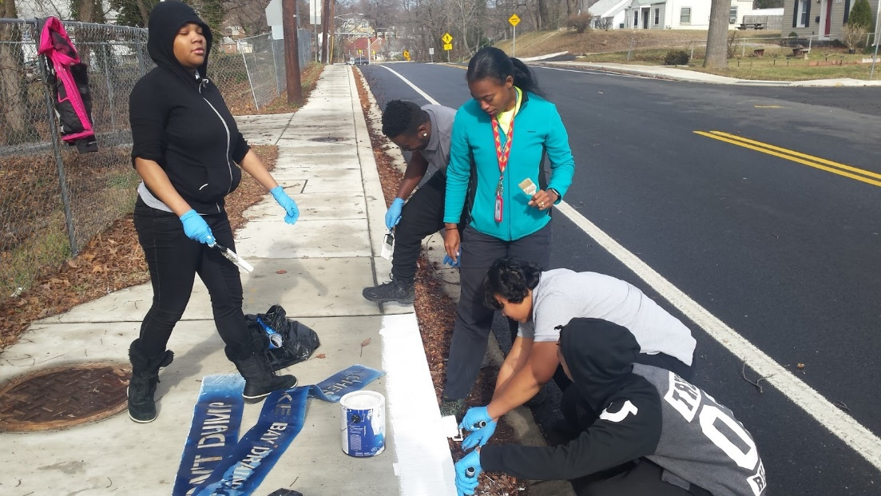

2.1. Water Conservation/Pollution Prevention
Indoor and outdoor water usage and pollution prevention- smarter water use, stormwater management and erosion control, identifying and implementing solutions that reduce our impact on the Chesapeake Bay Watershed.
Required: Information and documentation of students or other clients performing and participating in activities. Each example of Demonstrated Sustainable Practices needs to include a few sentences describing the activity, grade level, number of students who participated and approximate date. Each activity should include at least one piece of labeled documentation. Photo documentation is strongly encouraged.
Examples:
- Students are taken through a stormwater tour, viewing the stormwater infrastructure established in the center
- Students participate in a pervious concrete hands-on activity in a parking lot
- Students remove litter from center grounds, local parks, and streams with the activity
- focused on removing that litter before it reaches the waterways (stream restoration
- Students learn about the rain garden or no mow zone at the site
- Students conduct erosion-control projects such as installing riparian buffer zones,
- planting trees or creating meadow habitat
- Students learn about water saving techniques or grey water via signage near center sinks and water fountains
- Other examples of how students are using the center to actively participate in learning how a watershed works and how it is affected by pollution

2.2. Energy Conservation
Energy use and Climate Change. Examine facility and individual energy use, identifying and implementing solutions that reduce our carbon footprint.
Required: Information and documentation of students or other clients performing and participating in activities. Each example of Demonstrated Sustainable Practices needs to include a few sentences describing the activity, grade level, number of students who participated and approximate date. Each activity should include at least one piece of labeled documentation. Photo documentation is strongly encouraged.
Examples:
- Students participate in a tour of the center’s solar panels or a discussion of alternative energy resources
- Students do an activity involving the center’s energy-saving practices
- Students do a center-wide scavenger hunt to find energy conservation sustainable practices
- Student do a daylight investigative measurement activity
- Students perform classroom jobs to save energy, such as turning off lights & computers or closing the blinds (documentation could include a list of jobs posted in the classroom)
- Students learn about energy-saving techniques via labeled light switches

2.3. Solid Waste Reduction
Resource use, waste disposal and waste management. Examine resource use, identifying and implementing solutions that reduce the waste stream.
Required: Information and documentation of students or other clients performing and participating in activities. Each example of Demonstrated Sustainable Practices needs to include a few sentences describing the activity, grade level, number of students who participated and approximate date. Each activity should include at least one piece of labeled documentation. Photo documentation is strongly encouraged.
Examples:
- Students learn about and/or participate in center composting
- Students participate in “no-waste lunch” competition at the center
- Students weigh and compare personal waste while at the center
- Students repurpose used materials into art projects
- Students participate in litter pick-ups that focus on sorting recyclables out of the litter
- Students create their own recycled paper
- Student jobs include regularly monitor, track, and/or manage the center recycling bins

2.4. Habitat Restoration
Native plant and animal habitat. Identifying and implementing solutions that improve or restore habitat, with education on the benefits to the local ecosystem or watershed.
Required: Information and documentation of students or other clients performing and participating in activities. Each example of Demonstrated Sustainable Practices needs to include a few sentences describing the activity, grade level, number of students who participated and approximate date. Each activity should include at least one piece of labeled documentation. Photo documentation is strongly encouraged.
Examples:
- Students participate in native garden program/activity
- Students plant native trees or native bay grasses
- Students tour the center grounds and learn about nesting boxes, rotting log habitat, oyster reef balls, no mow zones or other habitat restoration structures
- Invasive plant removal projects
- Students plant or tend a pollinator garden on the center grounds (e.g. native plant, butterfly/pollinator gardens)
- Raising native species (e.g. trout or terrapins) in the classroom for release or planting
- Students learn about amended windows that prevent bird strikes
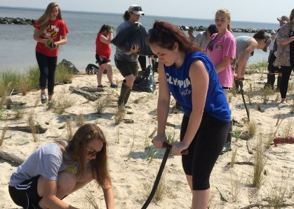
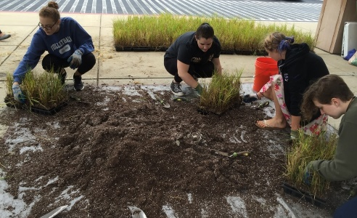

2.5. Structures for Environmental Learning
Designing and installing structures that encourage the use of outdoor space for environmental learning, restoring habitat, and returning habitat diversity.
Required: Information and documentation of students or other clients performing and participating in activities. Each example of Demonstrated Sustainable Practices needs to include a few sentences describing the activity, grade level, number of students who participated and approximate date. Each activity should include at least one piece of labeled documentation. Photo documentation is strongly encouraged.
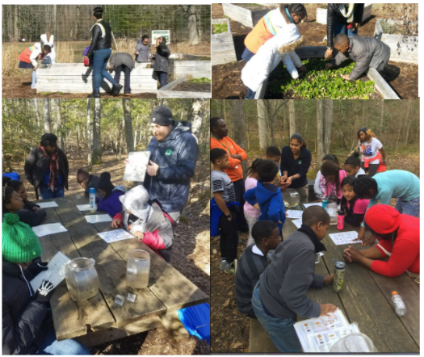
Examples:
- Students regularly work outside in an outdoor classroom or outdoor park
- Students use an outdoor boardwalk, research boat, pavilion, nature trails, living shorelines, observation hives, green roof, etc. to learn about environmental education
- Students plant, maintain and/or harvest food in gardens at the center (salad tables, raised bed gardens, in-ground gardens, etc.)
- Students create outdoor artwork for schoolyard/outdoor classrooms

2.6. Responsible Transportation
Designing and promoting responsible and healthy options for center and visitor transportation.
Required: Information and documentation of students or other clients performing and participating in activities. Each example of Demonstrated Sustainable Practices needs to include a few sentences describing the activity, grade level, number of students who participated and approximate date. Each activity should include at least one piece of labeled documentation. Photo documentation is strongly encouraged.
Examples:
- Center policy is that all students are dropped off via bus
- Informational signage displays reasoning for a no idle zone
- Students survey and analyze the carbon footprint of center transportation methods
- Center promotes and hosts students for international walk-to-school day

2.7. Healthy School Environment
Promoting healthy indoor and outdoor environment by examining and using different types of cleaners, pesticides, lighting options, drinking water quality, ventilation, food sources, purchasing options, and maintenance choices.
Required: Information and documentation of students or other clients performing and participating in activities. Each example of Demonstrated Sustainable Practices needs to include a few sentences describing the activity, grade level, number of students who participated and approximate date. Each activity should include at least one piece of labeled documentation. Photo documentation is strongly encouraged
Examples:
- Sustainable eating activities and lessons
- Students participate in a community clean-up
- Healthy Snack program in lunch room
- Outdoor activity and exercise program
- Students learn how to make and use non-toxic or green cleaning products
- Center hosts an outdoor running or other health club that utilizes the center grounds and encourages the students to spend time outdoors.

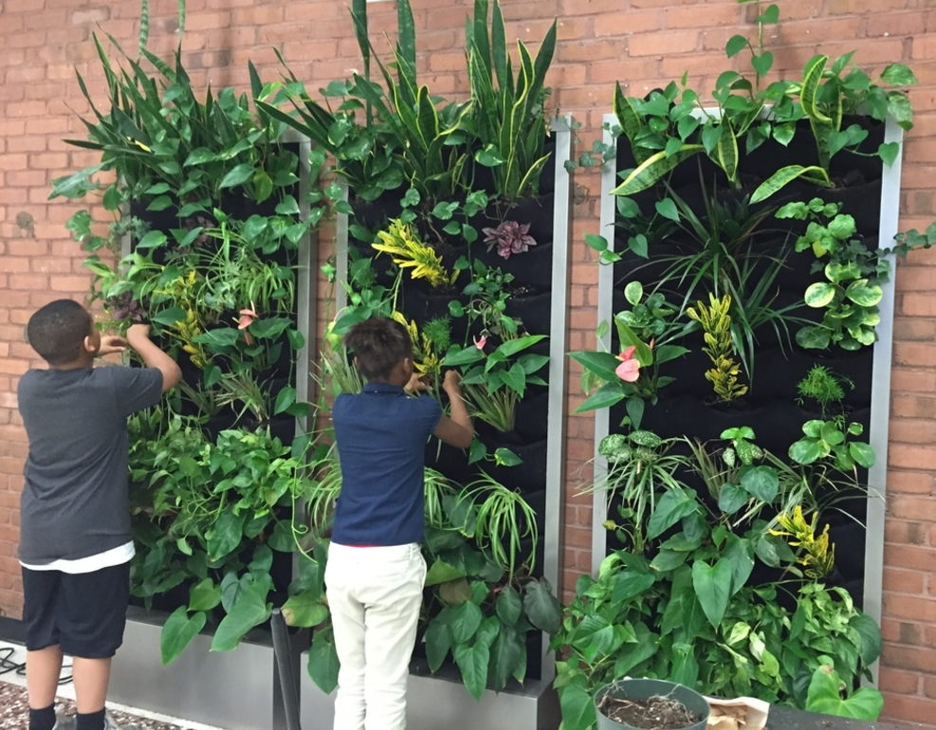

Objective 3: Community Partnerships, Awards and Special Recognition
Community partnership are important for schools to be successful in building long-term sustainable practices.

3.1. Community Partnerships
Demonstrate how you are collaborating with your school community and other partners. This may include examples listed in objective 1 showing how you have supported schools.
Required: Two specific partnerships with schools or other community partners
Examples:
- Providing environmental based programming for schools
- Assisting at school event (e.g. hosting a booth at an earth day celebration)
- Financial support and/or assisting with grant information and grant writing
- Providing materials, trees, plants, volunteers
- Providing technical support for planning and implementation of projects
- Providing contacts and connections to the appropriate resources to help schools become more environmentally aware
- Partnering with schools to design solutions to environmental issues in the community
- Providing projects suitable for students to earn Student Service Learning hours
- Modeling, co-teaching, and/or creating lessons and activities with teachers
- Providing Professional Development Opportunities for Teachers
- Assist schools with the Green School Application
- Receive a Grant to assist with Environmental Sustainability Projects (Grantor is the partner)
- Mentoring new Green Centers with their applications
- Partnering with other Green Centers
- Partnering with community or other organizations for clean ups and other environmental projects

Ideas for Documentation:
- Photos of students and community partners working together on an environmental education or sustainability practice activity
- Student reflections about the activity
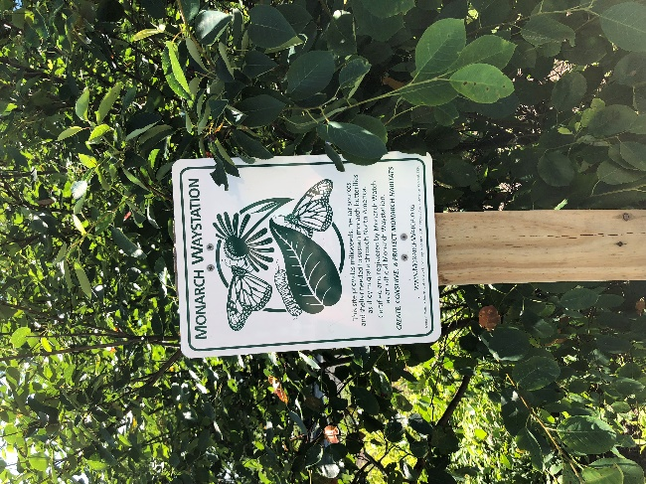
- Newspaper/newsletter articles
- Email or other correspondence with the partner
- Student work

3.2. Awards and Special Recognition (Optional)
Optional: Information here enhances your application. If your center has received awards or special recognition, include a few sentences describing the award. Each award should include at least one piece of documentation.
Examples:
- Community Wildlife Habitat Award from NWF
- County awards (e.g. “A” grade on recycling from the county)
- Measurable energy savings awards
- National awards
- Environmental Grants

Ideas for Documentation:
- photos of the award or of a special recognition event
- newspaper/newsletter articles
- copy of certificate/award

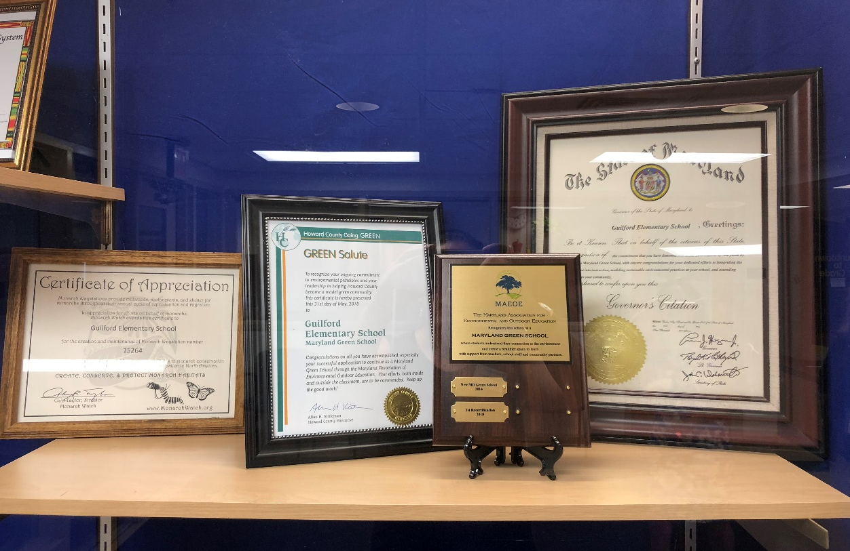

Guide to Maryland Green Center Documentation

The key to remember is that with this application you are documenting all of the work and activities that you are doing throughout your school and school community. You must document EVERYTHING that you say in your application. Applications are reviewed by professionals who do not know your center, they will follow a rubric and will only have the information that you provide.
If you say something, but do not include documentation (proof) of it, that information will not be considered towards receiving your certification.
DO: | DON’T:
- Make sure that everything you say is backed up by documentation!  - Caption every piece of documentation:  - date  - number of people involved (specific names of staff required for PD)  - description of activity  - Use strong documentation:  - photos  - student work/reflections  - dated correspondence (with student involvement proven if necessary)  - newspaper/newsletter articles reporting on a completed activity  - certificates/awards  - (for PD): agendas with sign-in sheets  - (for PD): certificates of completion/participation  - (for PD): email registrations/ confirmations of attendance | - Include any information without documenting it  - Include uncaptioned documentation  - Include lesson plans for an objective without other documentation (ONLY include if accompanied by other documentation that proves the activity actually happened and shows how the students were involved/responded to the activity)  - Include documentation that does not prove an activity happened. It does not strengthen the application (and may, in fact, weaken it). Examples of non-documentation that should not be included:  - images copied off the internet (instead, use photos of your students at work)  - descriptions of programs copied off the internet (instead, use your students’ photos or reflections about the program)  - flyers or emails advertising PD’s (instead, use specific proof that a specific staff member attended the PD)  - curriculum created by the school system and used by the whole system (it doesn’t prove that a school is taking special steps to be green – except when enhancing Objective 1.2)

IMPORTANT FILING INFORMATION AND DATES FOR 2018/19
Maryland Green School Application Dates:
- Application fee of $100 must be paid to MAEOE by December 14, 2018.
  - Centers that applied in Spring 2018 and are resubmitting in the 2018/2019 school year will not be required to file an additional application fee. However, please contact greenschools@maeoe.org to confirm your fee status and intent to apply.
  - Click here for the intent to apply.
- On-line applications are preferred. See the MAEOE website for examples.

- Send all electronic applications to applications@maeoe.org. The Application’s Cover Sheet, One Page Summary and Top 5 should be a separate attachment/file from the main application. All pieces of the application can be attached to the same email. Please send to applications@maeoe.org or MAEOE, 10015 Old Columbia Road, B-215, Columbia, MD 21046.

- Due Date: Electronic applications and hand-delivered applications are due to MAEOE by March 18, 2019. PowerPoint applications (saved on discs or data sticks) that are being mailed to MAEOE must be postmarked by March 18, 2019. Applications received after March 18, 2019 and mailed applications postmarked after March 18, 2019, are not guaranteed review.

- You will receive a confirmation email within two weeks. Because of the number of applications we receive on the due date, you are not guaranteed a confirmation until March 25. If you do not receive this confirmation by April 1, please send an email to applications@maeoe.org

- SAVE THE DATE!!!!! Maryland Green School Youth Summit, Thursday, May 30, 2019, 9am – 2pm. Information about previous Maryland Green School Youth Summits can be found at https://maeoe.org/green-schools-and-green-centers/maeoe-annual-youth-summit.

Thank you for your support of the Maryland Green School award program, a sustainable green schools program that demonstrates school progress with the Maryland Environmental Literacy requirement as set forth in COMAR 13A.04.17.

