2019-2020 Guide
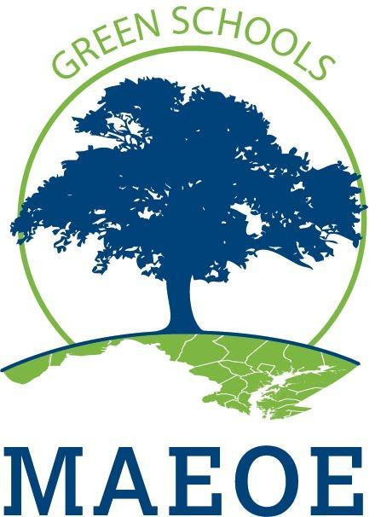  MARYLAND GREEN SCHOOL PROGRAM | A guide for the Maryland Green School Application. The application has been broken into sections so that you can print off the parts as needed.  Maryland Association for Environmental and Outdoor Education

Guide to Maryland Green School Documentation
Remember that in this application you are documenting all of the work and activities throughout your school and school community. You must document EVERYTHING that you say in your application. Professionals who do not know your school review applications; they follow a rubric and only have the information that you provide.
If you say something, but do not include documentation (proof) of it, that information will not be considered towards receiving your certification.
DO: | DON’T:
- Make sure that everything you say is backed up by documentation!  - Caption every piece of documentation:  - date  - number of people involved (specific names of staff required for PD)  - description of activity  - Use strong documentation:  - photos  - student work/reflections  - dated correspondence (with student involvement proven if necessary)  - newspaper/newsletter articles reporting on a completed activity  - certificates/awards  - (for PD): agendas with sign-in sheets  - (for PD): certificates of completion/participation  - (for PD): email registrations/ confirmations of attendance  - Include students in gathering documentation and organizing it in your application | - Include any information without documenting it  - Include uncaptioned documentation  - Include lesson plans for an objective without other documentation (ONLY include if accompanied by other documentation that proves the activity actually happened and shows how the students were involved/responded to the activity)  - Include documentation that does not prove an activity happened. It does not strengthen the application (and may, in fact, weaken it). Examples of non-documentation that should not be included:  - images copied off from the internet (instead, use photos of your students at work)  - descriptions of programs copied off from the internet (instead, use your students’ photos or reflections about the program)  - flyers or emails advertising PD’s (instead, use specific proof that a specific staff member attended the PD)  - curriculum created by the school system and used by the whole system (it doesn’t prove your school is taking special steps to be green – except when enhancing Objective 1.2)

Contents
Guide to Maryland Green School Documentation 1
Introduction 3
Getting Started: New and Recertifying Schools 4
Application Checklist: New and Recertifying Schools 5
IMPORTANT FILING INFORMATION AND DATES FOR 2019-2020 6
Green School Application Objectives Checklist 6
Application Objectives 7
Objective 1: Systemic Sustainability 7
1.1 Curriculum and Instruction: Environmental Issue Instruction 7
1.2 Professional Development 8
1.3 Sustainable Schools 10
1.4 Celebration 11
Objective 2: Student-driven Sustainability Practices 12
2.1. Water Conservation/Pollution Prevention 14
2.2. Energy Conservation 14
2.3. Solid Waste Reduction 15
2.4. Habitat Restoration 15
2.5. Structures for Environmental Learning 15
2.6. Responsible Transportation 16
2.7. Healthy School Environment 16
2.8 Citizen Science / Community Science 16
Objective 3: Community Partnerships, Awards and Special Recognition 17
3.1. Community Partnerships 17
3.2. Awards and Special Recognition (Optional) 19

Introduction
The Maryland Association for Environmental and Outdoor Education (MAEOE) is a non-profit organization that has been in existence since 1985. MAEOE encourages, engages, and empowers the community to understand, responsibly use and promote the natural world.
The MAEOE Maryland Green School award program was started in 1999. The Maryland Green School award program allows a school to demonstrate that by integrating hands-on, inquiry-based instruction, youth are empowered to practice environmental sustainability. At school, home, and in their communities, schools are reducing pollution, decreasing waste, increasing habitat, limiting carbon emissions, creating healthy learning and living environments and supporting environmental literacy. The program is designed to highlight achievements and progress that schools are making towards environmental sustainability, aligned with the Maryland Environmental Literacy graduation requirement as set forth in COMAR 13A.04.17.01 and the Environmental Literacy Goal established in the Chesapeake Bay Agreement. By providing Environmental Education, Maryland teachers and partners enable students to make decisions and take actions that create and maintain a positive relationship between themselves and the environment. Maryland’s students, teachers, families, and those who work at the schools are all involved in the preservation and protection of the state’s unique natural resources, particularly those of the Chesapeake Bay and its watershed. Find more information about the Environmental Literacy Standards here.
Keep in mind that multiple parts of your application connect with Maryland College and Career Ready Standards including:
- NGSS (Next Generation Science Standards) curriculum
- Maryland Content Standards
- C3 curriculum
- STEAM curriculum (Science Technology Engineering Arts and Math)
- Pressing environmental issues including climate change, decreasing biodiversity, nitrogen cycle, aquifer depletion, endangered species, habitat loss and other issues
- Meaningful Watershed Educational Experience
- Chesapeake Bay Backpack Resources

Throughout the application, you will find examples that show some of these connections

The Association of Independent Maryland & DC Schools (AIMS) recognize that an understanding of the natural world and the impact humans have upon it is an educational and institutional value. Accordingly, we encourage our schools to foster and support substantive environmental education experiences for all students and to seek to model sustainable practices within our physical plant operations and our school leadership practices.
- August 2019

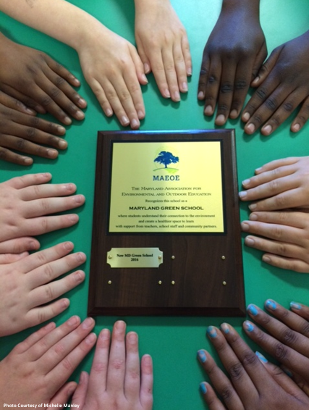
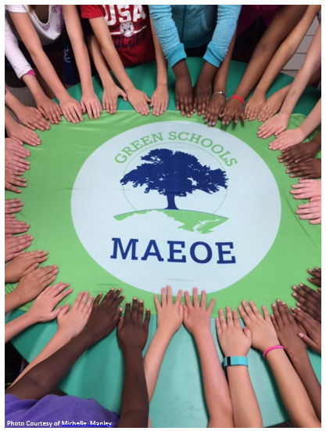

Getting Started: New and Recertifying Schools

- Contact your Green Center or Green Leader. Your Green Center or Green Leader can provide assistance with the application process. See MAEOE’s website for a list of Green Centers in your area. Please note: If you are recertifying, MAEOE strongly recommends that you speak with a Green Center or Green Leader at least once during your process. Successful applicants have used a Green Center or Green Leader to review their applications or give assistance at least once.
- Establish your school’s green baseline by making a list of all green activities from the past two years, including photos. This will help you put your application together.
  - If this is your first certification (new school), you will need information and documentation from this school year and the previous school year (fall 2018-spring 2020).
  - If this is a recertification, you should include information and documentation from this school year and the previous school year (fall 2018-spring 2020). You may include information and documentation from fall 2016-spring 2018.
- Set up an electronic application to log your school’s green information and documentation. Applications can be in the form of a website, Weebly, Google Slides, PowerPoint, or similar method. This can be updated by the Green Team or school members as events/actions/training occur over the two-year process. For electronic templates and example applications visit the Green School Application Page on the MAEOE website.
- Maryland Green School teachers and students are required to input their school’s Sustainable Practices into our Metrics Collection Survey. This will allow MAEOE to quantify Maryland students’ green achievements through data tracking (e.g. the number of trees planted, miles of streams cleaned, pounds of trash collected). This data can then be used to find inspiration in other school’s projects and see the impact MD Green Schools have on the environment. See page 6 for more info and the link.
- Consider applying for joint certification with Eco-Schools USA. The MAEOE/Eco-Schools partnership provides national and international networking opportunities, additional resources to support your school and curricula greening efforts in Maryland, and increased visibility for your school and students. Click here for more information about the partnership and the benefits your school can gain from participating.
- File your Intent to Apply and pay the fee by December 18, 2019. The fee of $75 must be paid to MAEOE either by check or credit card. See page 6 for more details about filing the intent to apply.

For Frequently Asked Questions about the Application please go to FAQ's.
If you are considering becoming a Maryland Green School for the first time look at these resources.
For specific inquiries, contact your local Green Center or email greenschools@maeoe.org

Application Checklist: New and Recertifying Schools
Complete and submit the following required application materials.
___ Intent to Apply Fee: Fee of $75 must be paid to MAEOE by December 18, 2019. See page 6 for more details about filing the intent to apply.
___ Cover Sheet: must have an original signature by the principal. Please submit this separately from your application (either by email or mail). You are welcome to also embed it into your application. You will find this on the Green Schools Application Page.
___ Brief summary: This is a one-page report describing your school’s green culture and the examples of sustainable changes that the school has made to become greener. Please submit no more than one page within the main application.
___ Brief top five accomplishments bullet-list: please include one sentence for each of the accomplishments. Please submit no more than one sentence for each bullet point within the main application and in the Metrics. These will be read at the Youth Summit Awards Ceremony.
___ Metrics Collection: Review this PDF of the Metrics Collection to collect all the information before starting. Then enter your data and “Top Five” accomplishments into the Survey Monkey Metrics Survey here.
___ Documented Application Objectives: your application will be evaluated using the rubric on the information AND documentation that your school provides for each objective. Documentation must be fully explained with appropriate captions. In your application, do not forget dates and number of students involved. Examples of how you can meet the objectives are found on pages 7-19. Past applications and the rubric can be found on the Green Schools Application page at www.maeoe.org. Applications are due no later than March 17, 2020.

IMPORTANT FILING INFORMATION AND DATES FOR 2019-2020

- Application fee of $75 must be paid to MAEOE by December 18, 2019. Click here for the intent to apply.
  - Schools that applied in Spring 2019 and are resubmitting in the 2019-2020 school year do not need to file an additional application fee. However, please contact greenschools@maeoe.org to confirm your fee status and intent to apply.

- Electronic applications are required. Online (web) applications are preferred. See the MAEOE website for examples and templates.

- Send all electronic applications to applications@maeoe.org. The Application’s Cover Sheet One Page Summary and Top 5 accomplishments should all be included in the main application. You may send thumb drives to applications@maeoe.org or MAEOE, 3430 2nd Street, Suite 300, Baltimore, MD 21225.

- Due Date: Electronic applications are due to MAEOE by March 17, 2020. PowerPoint applications (saved on USB Drives) that are being mailed to MAEOE must be postmarked by March 17, 2020. Applications received after March 17, 2020 and mailed applications postmarked after March 17, 2020 are not guaranteed a review.

- If you have established contact with your local Green Center or Green Leader, please direct application questions to them. If you do not have a Green Center or Green Leader, contact greenschools@maeoe.org and we will see who is available in your area.

- You will receive a confirmation email by no later than two weeks after you submit your application. Due to the number of applications we receive, you are not guaranteed a confirmation until April 5. If you do not receive this confirmation by April 5, please send an email to applications@maeoe.org.

- SAVE THE DATE!!!!! Maryland Green School Youth Summit, Thursday, May 28, 2020, 9am – 1pm. Information about previous Maryland Green School Youth Summits can be found here.

Thank you for your interest in the Maryland Green School award program, a sustainable green schools program that demonstrates your schools progress with the Maryland Environmental Literacy requirement as set forth in COMAR 13A.04.17.

Green School Application Objectives Checklist
This is a checklist to organize your school’s application and is available online. To access it, click here.

Application Objectives

Objective 1: Systemic Sustainability
Curriculum and Instruction, Professional Development, Sustainable Schools, and Celebration

1.1 Curriculum and Instruction: Environmental Issue Instruction
Demonstrate that outdoor, environment-based instruction, and Meaningful Watershed Education Experiences are occurring through hands-on, authentic lessons on environmental issues. (see MSDE Environmental Literacy Standards). MAEOE supports the integration of environmental literacy into school curriculum. It is essential to connect environmental topics to MD Academic Standards (Next Generation Science Standards (NGSS), MD College and Career Readiness Standards, STEAM). Use examples found in your curriculum and document student learning in your application. See examples and resources here.
Other resources:
Meaningful Watershed Educational Experiences (MWEEs) are learner-centered experiences that focus on investigations into local environmental issues that lead to informed action and civic engagement. Teachers play an important role in presenting unbiased information and assisting students with their research and exploration. Four essential elements and four supporting practices build upon each other to create this comprehensive learning experience for students. You can find more information about MWEEs here. For those that are not yet familiar with the MWEE please consider taking this online MWEE course about the MWEE (1 MSDE CPD is available for the completion of this course).
Climate Change: Did you know that you and your students can take action to address climate change and other pressing environmental issues, including decreasing biodiversity, nitrogen cycle, aquifer depletion, endangered species, habitat loss and more? For example, planting trees not only provides shade, habitat, and oxygen, but trees also take carbon dioxide from the atmosphere and store it for decades. You can find standards-linked lessons about climate change, workshops and more here.
Citizen Science Example: Get your students involved in The GLOBE Program and have them help NASA scientists better understand how our home planet is changing over time. Not only will they be able to collect environmental data, such as air temperature and precipitation, but they will also be able to compare and contrast their data to that of scientists and other students around the world. Blend technology and data collection using the GLOBE Observer app and engage students in involving their families and communities in better understanding and documenting their natural environment.
Required: At least one example of outdoor and/or classroom environmental investigations instruction per grade level for elementary and middle school; OR in at least four subjects for high school (can be non-science subjects, but can also be multiple science subjects, for example chemistry and biology) with a brief explanation of how students are using the environment as a context for learning. Document each example.
In this section we strongly encourage applicants to describe the MWEEs students are participating in; the goal is that all students participate in a MWEE during each grade band (ES, MS and HS).
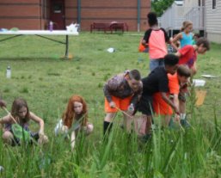
Acceptable: ES/MS: Instruction in all grades (all students receive environmental instruction)
HS: Instruction in at least 4 courses or subject areas, not all science, ideally with an outdoor component (all students receive environmental instruction). You must demonstrate that all students will receive environmental instruction at some point in their time at high school in biology or other courses (four subject areas). Reviewers want to see that all students receive environmental instruction.
Good: ES/MS: all grades, multiple subjects/contents
HS: more than 4 subject/content areas
Excellent: ES/MS: all grades, all subjects/contents
HS: all subject/content areas

Examples:
- A description of a MWEE, using the Environmental Literacy Model (or other format) that describes how students are participating in the Essential Elements of a MWEE: Issue Definition, Outdoor Field Experiences, Synthesis and Conclusions, and Stewardship and Civic Action.
- Cross curricular activities that investigate the environment (e.g. calculate area of solar panels in math, research the history of energy use in social studies, etc.). For example, having your students conduct an investigation on their school grounds that would support a MWEE; then, using their findings, have them write a short story or poem about their experience.
- Using schoolyard, community, or field trip locations for outdoor education integrated into the curriculum.
- Incorporating outdoors in artwork or music education.
- Activities that connect pressing environmental topics such as climate change, decreasing biodiversity, nitrogen cycle and other issues within your curriculum. For example, students learn that planting trees not only provide shade, habitat, and oxygen, but trees also take carbon dioxide from the atmosphere and store it for decades.
- Use the Mosquito Habitat Mapper tool to locate the potential mosquito breeding habitats in your schoolyard and in their homes and neighborhoods. Have them develop ways to educate their community to reduce the number of human-made mosquito breeding habitats.
- Compare and contrast the land cover and amount of precipitation students find in their school habitats to that of students from other countries to better understand weather and climate around the world.

Ideas for Documentation: (NOTE: ALL documentation should be captioned with text explaining the grade level/subject area and an explanation of the activity that describes how students are using the environment as a context for learning!)
- student work
- photos of students engaged in environmental learning
- student reflections on taking action

1.2 Professional Development
Demonstrate the staff is actively preparing to support your school’s environmental literacy plan to help fulfill the state’s environmental literacy requirement AND that all school knows about the MAEOE Maryland Green School process
Required: 1.2.1 All staff are aware of the Green School application process. MAEOE Green Leader or school Green Team leader should present information at all school staff meeting.
1.2.2 At least 10% of teachers have participated in an Environmental Education PD (for new schools), continue commitment to Environmental Education PD (for recertifying schools) over a 4 year period
Optional: 1.2.3 Additional Professional Development
***Information should include dates, length of time, teachers’ names, grade levels,
and numbers of teachers. ***
Acceptable: 1.2.1: All Staff Know
1.2.2: 10% of teachers have EE PD
1.2.3: One example (Optional)
Good: 1.2.1: 2-3 Staff Meetings
1.2.2.: 20% of teachers have EE PD
1.2.3 Two-four examples (Optional)
Excellent: 1.2.1: 3+ Staff Meetings
1.2.2: 30% of teachers have EE PD
1.2.3 More than 4 examples (Optional)
Examples:
1.2.1 All staff are aware of the Green School application process
- Staff meeting agenda includes Green School application update
- Whole staff presentation on Maryland Green Schools Program provided by a Green Center/Green Leader
- Collaborative lesson planning involving environmental/Green School components
- Principal, teachers, students or Green Leaders present at PTA meetings
- Doesn’t have to be all at one time, may be over the course of two years and several meetings

1.2.2 At least 10% of teachers have participated in Environmental Education PD during the certification process.
- Staff member(s) attend(s) MAEOE conference
- Staff complete the MWEE 101 Course and attach certificate of completion
- Staff attend environmental education workshops (e.g. Project WET, Chesapeake Classrooms, POW!, Master Naturalist, Project Learning Tree, Food, Land and People, Chesapeake Bay Foundation Professional Development, etc.). Find more examples on the MAEOE Professional Development Calendar or talk to your local Green Center
- Staff create accounts with The GLOBE Program and complete online training
- Lesson modeling in classrooms from Green Centers or other partners
- Environmental speakers presenting at staff meetings or workshops (NOT at school wide assemblies with students) **Consider speaking with your Green Leader to see if this is a possibility for them**
- Environmental education-focused webinars
- Climate change solutions
- GLOBE Training

1.2.3 Additional Professional Development (Optional) - Received earlier than 4 years ago. NOTE: These additional professional development activities do not count in the 10% requirement in 1.2.2
- Bachelor’s or other degrees in Environmental Science
- Environmental education professional development course (e.g. Project WET, Chesapeake Classrooms, POW!, Master Naturalist, The GLOBE Program, Project Learning Tree, Food, Land and People, Chesapeake Bay Foundation Professional Development, etc.)
- MAEOE Environmental Educator Certification

Ideas for Documentation: (NOTE: ALL documentation should be captioned with the specific names of staff involved, dates, and any necessary explanation of the activity!)
- agendas
- certificates of completion or participation
- email confirmations/registrations
- sign-in sheets
- dated, signed notes taken at a PD

1.3 Sustainable Schools
These demonstrate your school’s goals towards being sustainable.
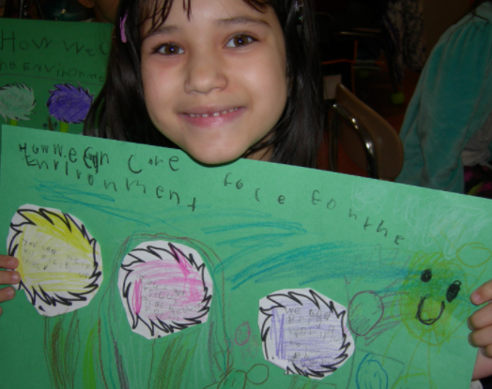
Required: 1.3.1 School Wide Environmental Behavior Change
1.3.2 Systemic Partnership
Acceptable: 1.3.1: One Example
1.3.2: One Example
Good: 1.3.1: Two-three examples
1.3.2: Two-three examples
Excellent: 1.3.1: Four or more examples
1.3.2: Four or more examples

1.3.1 School-Wide Environmental Behavior Changes
Demonstrate the steps your school has taken school-wide to make your school green. These examples are non-student driven sustainability practices. If there is student involvement, then the actions should be documented under student-driven sustainability practices in Objective 2.
Examples:
- Staff using electronic newsletters and implementing policies to reduce paper use (i.e., double-sided copying)
- Task lamps, day lighting (use of natural light), de-lamping (purposeful removal of ½ of light bulbs), or energy saver mode on electronics used by all teachers to save energy
- Installation of energy-efficient lighting or motion-sensitive lights
- Integrated pest management
- Two-sided copying
- Staff carpooling or public transportation incentive program
- Reduction of impervious surfaces (blacktop, concrete) in the schoolyard
- Teachers using green cleaners in classrooms
- Installation of solar panels and/or green roof

Ideas for Documentation (NOTE: ALL documentation should be captioned with text explaining the grade level/subject area and any necessary explanation of the activity!):
- photos of the practices being implemented (i.e., photos of staff using daylighting)
- policies
- blueprints
- email or other correspondence

1.3.2 Systemic Partnership
Demonstrate one partnership within the school system that supports an aspect of the Maryland Green School Program. This partnership needs to reach beyond your individual school to the “higher” or Central Office level.
Examples:
- Sustainability Office
- Food and Nutrition Services
- Health and Wellness Office
- Physical Facilities
- School System Outdoor Education Department

Ideas for Documentation (NOTE: ALL documentation should be captioned with text explaining the grade level/subject area and any necessary explanation of the activity!):
- Application to install a garden/outdoor classroom/bluebird house/etc.
- Letter from Food and Nutrition Services about the farm to school program in the cafeteria
- Solid waste reduction plan from central office
- Letter from county science specialist offering materials for lessons

1.4 Celebration
Demonstrate how your school community celebrates being green.
Required: At least one school-wide, annual environmental event with a brief description of the celebration, the number of students involved. The date and labeled documentation need to be included.
Acceptable: One school wide event
Good: Annual/Multiple Events
Excellent: Community outreach component with annual/multiple events
Examples:
- The whole school celebrates International Walk to School Day each October
- The whole school celebrates Earth Day each April (classes can celebrate separately as long as they all celebrate)
- The whole school turns out the lights each March for Earth Hour
- A green school bulletin board is used to highlight green school activities (only acceptable in conjunction with other celebratory activities)
- Students participate in annual environmental poster contests (only acceptable in conjunction with other celebratory activities)
- Morning announcements regularly focus on green topics (only acceptable in conjunction with other celebratory activities)
- USGBC Green Apple Day of Service http://www.mygreenapple.org/

Ideas for Documentation: (NOTE: ALL documentation should be captioned with the specific names of students involved, dates, and an explanation of the activity!)
- newspaper/newsletter articles
- photos of students participating in celebratory activities
- awards
- agendas/plans/programs for events
- email correspondence/ invitations

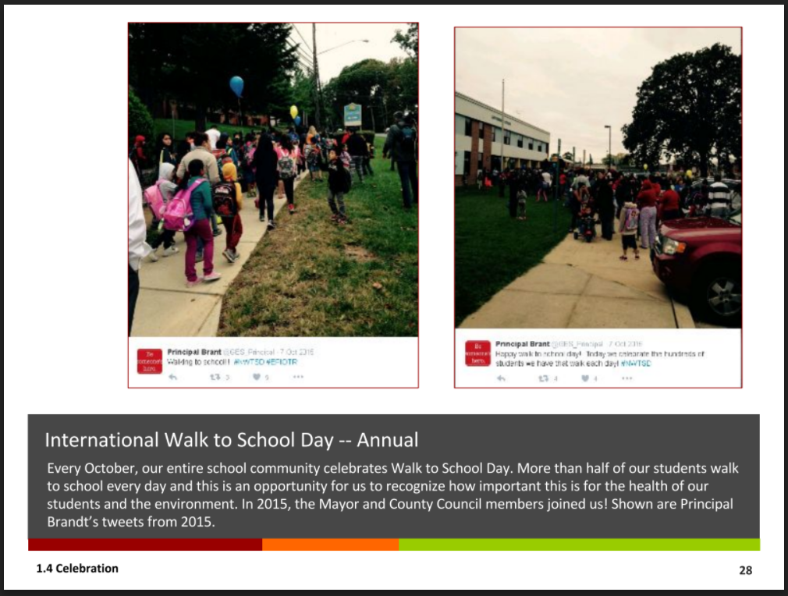

Objective 2: Student-driven Sustainability Practices
In this section, you will document student environmental actions and demonstrate that students are planning, implementing, and leading environmental practices. If your school has implemented a MWEE, these are the stewardship and civic action components of the MWEE in which the students have been involved.
Required: Two actions from at least FOUR (4) of the following eight (8) categories; Water Conservation, Energy Conservation, Solid Waste Reduction, Habitat Restoration, Structures for Environmental Learning, Responsible Transportation, Healthy School Environment, and Citizen Science/Community Science. Reviewers expect to see maximum student involvement possible based on ability and age of students. Each activity should be documented. The documentation should include a few sentences describing the activity, grade level, number of students who participated, and date.
Ideas for Documentation (NOTE: ALL documentation should be captioned with text explaining the grade level/subject area and any necessary explanation of the activity!):
- student work/reflections
- demonstration of the project development and/or project selection process (ex: students using dot voting to select an action OR students pitching an idea for action to a local expert through a presentation OR students identifying criteria for their action project)
- photos of students engaged in sustainability practices
  - photos of students designing a sustainability practice (e.g., drawing the design for an outdoor classroom that they later help build)
  - photos of students working to build a sustainability practice (e.g., installing a rain barrel, painting bird boxes, creating energy saving posters)
  - photos of students engaged in a sustainability practice activity (e.g., picking up litter, writing letters to administration or political representatives)
  - photos of students maintaining a sustainability practice (e.g., weeding and watering a habitat garden)
  - photos of student-created products that they developed and used to increase community/school wide awareness (e.g., protection and prevention of mosquito-transmitted disease)
  - DO NOT USE: photos of students simply standing next to a sustainability practice (unless you also include photos of the students creating it and are just including it as the final product photo or culmination of the process) – the students need to be actively engaged. If the sustainability practice was built prior to the application timeframe, you need to show that students are actively maintaining, continuing, and/or extending the practice.
- student-created blueprints/plans
- newspaper/newsletter articles
- artifacts illustrating the processes used by students to determine which stewardship and civic action opportunities they would pursue.
- Correspondence planning a project (NOTE: if the correspondence is between adults, it MUST be accompanied by proof of student involvement in the project)

NOTE:
- MAEOE recommends that Schools choose ONLY four out of the eight categories below (2.1 – 2.8). Schools that try to complete more than four categories frequently impact their documentation quality so it’s preferable to do four categories really well rather than more categories less well.
- Your application will be stronger if you include more than two actions/examples per chosen category!
- These are student actions not adult actions. Adult sustainable actions can be documented in section 1.3.1

Eco-Schools USA: Eco-Schools USA is an international sustainable schools recognition program working in partnership with MAEOE to support Maryland Green Schools. It provides a free framework for how to green your school, one sustainable practice (or pathway) at a time, and an opportunity to earn one of Eco-Schools tiered awards. Step into your Maryland Green School process by receiving a Bronze or Silver Eco-Schools USA Award.
To receive the Bronze Award, a school needs to complete one pathway. In order to receive the Silver Award, a school must complete two of the Eco-Schools pathways. New or existing Green Schools may be eligible to receive the Eco-Schools Green Flag. Contact Natalie at cohenn@nwf.org for more information.
Eco-Schools pathways align with the MAEOE Sustainable Practices. Please go to NWF Eco-Schools USA for more information.

2.1. Water Conservation/Pollution Prevention
Examples:
- Students plant rain gardens or conservation landscaping
- Students install and use rain barrels
- Students create and hang signage near school sinks and water fountains to encourage
water conservation
- Students remove litter from schoolyards, local parks, and streams with the activity
focused on removing that litter before it reaches the waterways (stream restoration)
- Students conduct erosion-control projects such as installing riparian buffer zones and
planting trees (stream restoration)
- Students stencil storm drains to prevent polluted water from reaching the streams
- Students plan and create no-mow zones with identifying signage (so it will not be mowed
accidentally)
- Students create hydroponic or aquaponic gardening systems

2.2. Energy Conservation
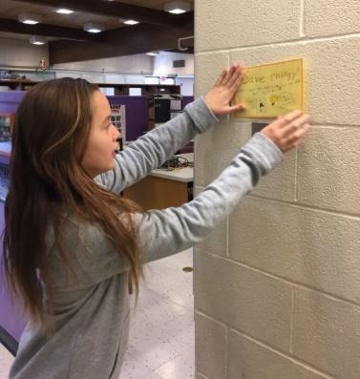
Examples:
- Students label the light switches throughout the school with signs or switch-plates encouraging energy conservation and reducing our impact on climate change
- Students implement the results of their energy audits or encourage decision-makers to implement actions based on their data collection
- Students perform classroom jobs to save energy, such as turning off lights & computers or closing the blinds (documentation could include a list of jobs posted in the classroom)
- Student group forms an “energy patrol” and issues “energy stars” to classrooms that turnoff lights or electronics
- Students plant trees to shade the building
- Students install energy-efficient lighting in computer labs or elsewhere in school
- Students create and read Energy Savings Tips on morning announcements

2.3. Solid Waste Reduction
Examples:
- Student Green teams regularly monitor, track, and/or manage the school recycling bins
- Students participate in no-waste lunches
- Students organize recycling drives for ink cartridges, cell phones, batteries, etc.
- Students participate in up-cycling programs such as TerraCycle
- Students create labels for recycling stations
- Students create posters to remind each classroom what to recycle
- Students monitor and maintain an outdoor compost bin or an indoor vermicomposting (worm compost) bin
- Students repurposed used materials into art projects
- Students create their own recycled paper
- Students advocate to hand in homework electronically or communicate via classroom blogs rather than with paper
- Students run a reusable water bottle campaign, encouraging other students to use water fountains and reusable water bottles instead of store bought plastic bottles
- Students create and/or run a school ReStore for unused school supplies

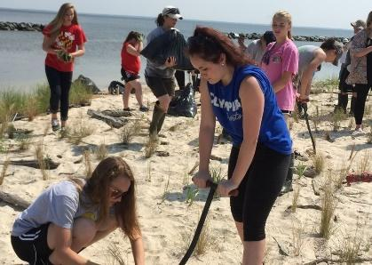
2.4. Habitat Restoration
Examples:
- Students plant or tend a native plant garden in schoolyard (e.g., native plant butterfly, pollinator gardens)
- Students plant native trees or native bay grasses
- Students install/monitor bird, bat, or butterfly boxes
- Students remove invasive plants from schoolyards or neighboring parks
- Students construct oyster reef habitat balls
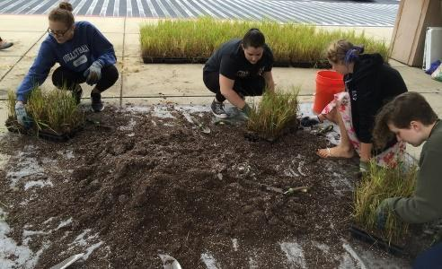
- Students regularly monitor and care for a rotting log or brush pile decomposer habitat
- Students build and monitor insect hotels
- Students create and monitor a bird habitat area with food, shelter, and water sources
- Students maintain and use schoolyard habitat

2.5. Structures for Environmental Learning
Examples:
- Students regularly work outside in an outdoor classroom (can be fixed or movable outdoor classroom)
- Students grow food in gardens at school (salad tables, raised bed gardens, in-ground gardens, etc.)
- Students advocate for green building infrastructure resources at their school, such as solar panels and green roofs
- Students create outdoor artwork for schoolyard/outdoor classrooms
- Students build and use a nature trail around their schoolyard
- Students post interpretative signage on interesting environmental features around the schoolyard (i.e.: erosion, decay, etc.)
- Students identify native trees or plants in the schoolyard and create a labeled identification trail or scavenger hunt

2.6. Responsible Transportation
Examples:
- Students survey, analyze and implement carbon reducing actions to improve school transportation issues
- Students create a no-idling zone by posting signage and handing out fliers
- Students run a bike safety program
- Students participate in Safe Routes to School activities to advocate for safe routes
- Students routinely go on walking field trips to reduce their carbon footprint and get to know local ecosystems, emphasizing the effects on climate change
- Students conduct tire pressure/oil leak checks on faculty vehicles and inform vehicle owners of results (improper tire pressure leads to greater fuel consumption)
- Students create carpool groups
- Students advocate for hybrid parking and/or carpool parking
- Students lead their school in the Idle Free MD Campaign

2.7. Healthy School Environment
Examples:
- Students make and use non-toxic or green cleaning products for classrooms
- Students grow and donate and/or eat healthy food in school gardens
- Students grow indoor plants to enhance air quality
- Students organize an outdoor running or other health club that utilizes the school grounds and encourages the students to spend time outdoors.
- Students create a poster campaign to encourage healthy eating choices while promoting the school’s garden and the importance of local, sustainable and organic farming (agriculture).
- Students host a “Recycling Olympics” or “Green Run” to encourage exercise and activity while incorporating environmental action.
- Students organize a community clean-up

2.8 Citizen Science / Community Science
Teachers initiate two or more activities that use GLOBE, GLOBE Observer, iTree, iNaturalist or other citizen science/ community science protocol to better understand the school environment and how citizen science/community science is used. Schools should have at least 1 staff member who has registered your school and completed any training required for engagement in these programs. Data submission to GLOBE/GLOBE Observer/iTree/iNaturalist/Creek Freak etc. that shows evidence of students having used at least two GLOBE/GLOBE Observer protocols or other protocols on a consistent basis over at least a two-month period or periodically over several months/years to document change over time. Photo documentation is strongly encouraged.
Examples:
- Students create a poster campaign to share “Best Practices” with others to learn about mosquito prevention and protection
- Students create a poster that shares the purpose of their citizen science/community science project and data collected.
- Students find solutions to modify locations in their school yard which are impacted by water runoff during rain events
- Students collect data about seasons as part of climate change citizen science and submit online
- Students look for and collect data on native ladybugs and submit information online
- Students survey trees on the school grounds and document their growth during the school year and submit information online
- Students take surface temperature measurements during the school year around the school grounds to demonstrate the positive impact of the shade from trees and other vegetation
- Students monitor their school environment for potential mosquito-breeding habitats and continually eliminate these when feasible
- Students develop solutions to improve soil as needed if their investigations show trees and vegetation on school grounds are not growing as they should
- Students create plans for landscaping on school grounds to increase the amount of green space and maximize the positive use of shade to reduce the urban heat island effects in their locations
- GLOBE Schools: Have students participate in the International Virtual Science Symposium and share what they have learned with other students, teachers, and scientists from around the world.

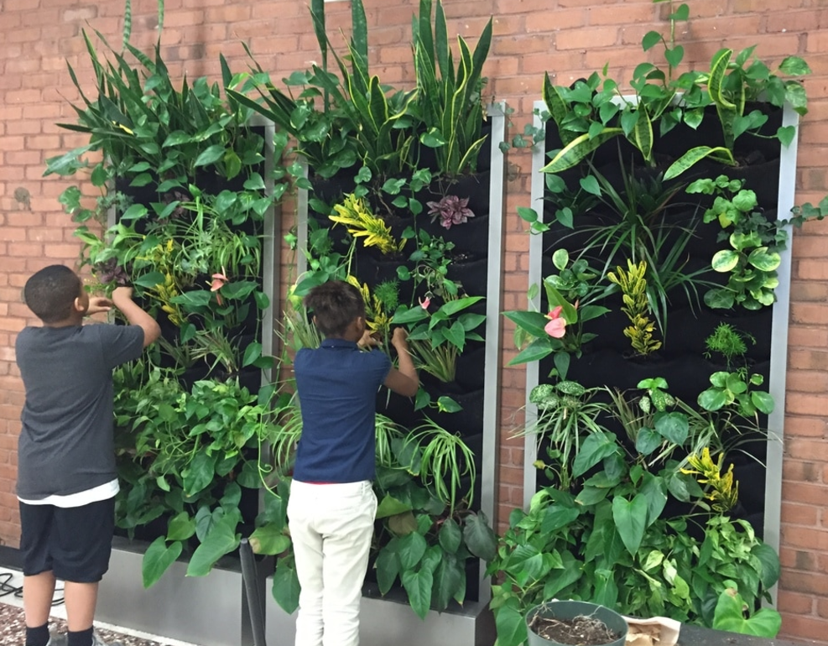

Objective 3: Community Partnerships, Awards and Special Recognition
Community partnerships are important for schools to be successful in building long-term sustainable practices.

3.1. Community Partnerships
Demonstrate who is collaborating with your school on environmental education.
Required: One sustained partnership where the partner is active in the school AND one sustained partnership where the school is active in the community (Can be the same partner organization or a different one). Photo documentation is strongly encouraged.
3.1.1 School Active in Community Examples:
- Students do environmental service projects off-site (e.g. stream clean-up, storm drain stenciling, invasive species removal, etc.)
- Used-Clothing Drive, with emphasis on reusing as conservation
- “Terrapins in the Classroom” project, release terrapins in the Bay (Other examples of similar programs include oysters, trout, monarchs and more)
- Fundraiser at the school to support community environmental projects
- Students run a letter writing campaign to political representatives
- Green Festival inviting the community to learn from students’ work
3.1.2 Community Active in the School Examples:
- Green Leader comes into the school to help with activities and/or the application
- Partner comes in to help set up an environmental project (e.g. bird boxes, rain gardens, edible gardens, outdoor classroom)
- Receive a grant for a school environmental project
- Environmental speaker comes to do an environmental education assembly
- Green Festival inviting the community to exhibit and present
Possible partners: This list includes suggestions – if there are other partners your school is working with to become a green school, feel free to use them!
  - Local Green Centers/Green Leaders
  - Alice Ferguson Foundation Trash Free Schools
  - County agencies (e.g. local USDA extension service, soil conservation district, health department, library, public safety [police and fire department])
  - State agencies (e.g. DNR, MDE, MSDE, Forestry Board)
  - Federal agencies (e.g. NOAA, EPA, USDA)
  - Local businesses (e.g. Lowes or Home Depot)
  - Local garden clubs or community organizations (e.g. garden clubs, Master Gardeners, Master Naturalists, 4-H)
  - Local parks, nature centers or Maryland-National Capital Park and Planning Commission
  - Non-profits (e.g. Chesapeake Bay Trust, Chesapeake Bay Foundation, Girl/Boy Scouts)
  - Colleges and universities
  - Energy companies, waste management companies or other

Ideas for Documentation (NOTE: ALL documentation should be captioned with text explaining the grade level/subject area and any necessary explanation of the activity!):
- photos of students and community partners working together on an environmental education or sustainability practice activity
- student reflections about the activity
- newspaper/newsletter articles
- email or other correspondence with the partner (should include dates, names and more)

3.2. Awards and Special Recognition (Optional)
Optional: Information here enhances your application. If your school or students have received awards or special recognition, include a few sentences describing the activity, grade level, number of students who participated, and date. Each activity should include at least one piece of documentation. (Not Required)
Examples:
- County awards (e.g. “A” grade on recycling from the county)
- Measurable energy savings awards
- National awards (e.g. Green Ribbon, Blue Ribbon, Eco-Schools USA, Healthy School Award)
- Specific Students recognized for Green efforts through scholarships, conferences, science fairs and more

Ideas for Documentation (NOTE: ALL documentation should be captioned with text explaining the grade level/subject area and any necessary explanation of the activity!):
- student work/reflections
- photos of the award or of a special recognition event
- newspaper/newsletter articles
- correspondence
- copy of certificate/award
